State of Florida |  | Public Service Commission  Capital Circle Office Center ● 2540 Shumard Oak Boulevard  Tallahassee, Florida 32399-0850  -M-E-M-O-R-A-N-D-U-M-
DATE: | June 6, 2024
TO: | Office of Commission Clerk (Teitzman)
FROM: | Office of the General Counsel (Rubottom) SMC  Division of Economics (Guffey) EJD  Division of Engineering (Brown) TB
RE: | Docket No. 20240080-EI – Proposed amendment of Rule 25-6.0183, F.A.C., Electric Utility Procedures for Generating Capacity Shortage Emergencies.
AGENDA: | 06/18/24 – Regular Agenda – Rule Proposal – Interested Persons May Participate
COMMISSIONERS ASSIGNED: |  |  | All Commissioners
PREHEARING OFFICER: |  |  | Clark
CRITICAL DATES: |  |  | None
SPECIAL INSTRUCTIONS: |  |  | None

Case Background
Rule 25-6.0183, Florida Administrative Code (F.A.C.), Electric Utility Procedures for Generating Capacity Shortage Emergencies, establishes the Florida Reliability Coordinating Council, Inc.’s (FRCC) Generating Capacity Shortage Plan (FRCC Plan) as the Commission’s plan to address generating capacity shortage emergencies within Florida. Staff initiated rulemaking to amend Rule 25-6.0183, F.A.C., for the purpose of incorporating by reference into the rule the updated, November 1, 2023, version of the FRCC Plan.
A Notice of Rule Development for this rule appeared in the February 12, 2024, edition of the Florida Administrative Register, Vol. 50, No. 29. No requests for a rule development workshop were made, and no workshop was held. This recommendation addresses whether the Commission should propose the amendment of Rule 25-6.0183, F.A.C. The Commission has jurisdiction pursuant to Sections 120.54, 366.04, and 366.05, Florida Statutes (F.S.).

Discussion of Issues

Issue 1:
Should the Commission propose the amendment of Rule 25-6.0183, F.A.C., Electric Utility Procedures for Generating Capacity Shortage Emergencies?

Recommendation:
Yes. The Commission should propose the amendment of Rule 25-6.0183, F.A.C., as set forth in Attachment A. The Commission should also certify that Rule 25-6.0183, F.A.C., is a rule the violation of which would be a minor rule violation pursuant to Section 120.695, F.S. (Rubottom, Brown, Guffey)

Staff Analysis:
The FRCC is a Florida not-for-profit company whose mission is to coordinate a safe, reliable, and secure bulk power system in the areas of Florida served by its members. The FRCC’s members include investor-owned, municipal, and cooperative electric utilities, as well as entities representing wholesale, generation, and load serving electric utility sectors. The FRCC serves as a registered Reliability Coordinator and Planning Authority for the North American Electric Reliability Corporation (NERC) within the service area of FRCC’s members. Prior to 2019, the FRCC also served as the regional entity with delegated authority from NERC for the purpose of proposing and enforcing reliability standards within the FRCC region; however, the FRCC transferred those functions in 2019 to the SERC Reliability Corporation.
The FRCC Plan, appended to this recommendation in Attachment A, is designed to document guidelines and summarize procedures to be used by governmental agencies and electric utilities within the FRCC Reliability Coordinator Area in response to generating capacity shortages which impact or threaten to impact significant numbers of customers. In particular, the FRCC Plan addresses the procedures of balancing authorities, generator operators, and transmission operators during a generating capacity shortage to ensure coordinated state-wide action and communication. As part of the FRCC Plan, the Commission acts as an informational liaison to all interested parties.
The FRCC Plan was revised effective November 1, 2023. Staff recommends the amendment of Rule 25-6.0183, F.A.C., to adopt and incorporate by reference the updated 2023 version of the FRCC Plan. The adoption of the most recent version of the FRCC Plan is the only substantive amendment to the rule, and other amendments are designed to provide clarity and consistency.
The November 1, 2023, FRCC Plan revises the Florida Transaction Management System (FTMS) definition as well as references to EOP-011-2, which addresses Emergency Preparedness and Operations. These changes affect Sections 6 and 8 of the plan. The 2023 plan also includes other revisions made to the plan since this rule was last updated by the Commission in May 2017, including to correct grammatical errors or inconsistencies, clarify responsibilities, and incorporate new or revised FRCC definitions.

Minor Violation Rules Certification
Pursuant to Section 120.695, F.S., for each rule filed for adoption, the agency head shall certify whether any part of the rule is designated as a rule the violation of which would be a minor violation. Rule 25-6.0183, F.A.C., is on the Commission’s minor violation rule list because violation of the rule would not result in economic or physical harm to a person or adverse effects on the public health, safety, or welfare and would not create a significant threat of such harm. The proposed amendments to the rule would not alter the likelihood or risk of such harms in the event of a violation. Thus, if the Commission proposes the amendment, staff recommends that the Commission certify that Rule 25-6.0183, F.A.C., is a rule the violation of which would be a minor violation pursuant to Section 120.695, F.S.

Statement of Estimated Regulatory Costs
Pursuant to Section 120.54, F.S., agencies are encouraged to prepare a statement of estimated regulatory costs (SERC) before the adoption, amendment, or repeal of any rule. Agencies are required to prepare a SERC for any rule that will have an adverse impact on small business or that is likely to directly or indirectly increase regulatory costs in excess of $200,000 in the aggregate within one year after implementation. The SERC analysis includes whether the rule will, within five years of implementation, have an adverse impact in excess of $1 million in the aggregate on economic factors such as economic growth, private sector job creation or employment, private sector investments, or business competitiveness, productivity, or innovation. If expected adverse impacts or regulatory costs exceed any of the above criteria, a proposed rule may not take effect until it is ratified by the Legislature.
A SERC was prepared and is appended hereto as Attachment B. The SERC concludes that the rule will not have an adverse impact on small business and that the rule is not likely to directly or indirectly increase regulatory costs in excess of $200,000 in the aggregate within one year after implementation. Further, the SERC concludes that the rule will not likely have an adverse impact on economic growth, private sector job creation or employment, private sector investment, or business competitiveness, productivity, or innovation in excess of $1 million in the aggregate within five years of implementation. None of the adverse impact or regulatory cost criteria set forth in Section 120.541(2)(a), F.S., will be exceeded as a result of the recommended amendments to the rule. Thus, the rule does not require legislative ratification pursuant to Section 120.541(3), F.S. In addition, the SERC states that the rule will have no impact on small cities or counties and will not increase the cost to the Commission to implement and enforce the rule. No regulatory alternatives have been submitted pursuant to Section 120.541(1)(a), F.S.

Conclusion
Based on the foregoing, staff recommends the Commission propose the amendment of Rule 25-6.0183, F.A.C., as set forth in Attachment A. In addition, staff recommends that the Commission certify that Rule 25-6.0183, F.A.C., is a rule the violation of which would be a minor violation pursuant to Section 120.695, F.S.

Issue 2:
Should this docket be closed?

Recommendation:
Yes. If no requests for hearing or JAPC comments are filed, and no proposal for a lower cost regulatory alternative is submitted, the rule may be filed with the Department of State for adoption, and the docket should be closed.

Staff Analysis:
If no requests for hearing or JAPC comments are filed, and no proposal for a lower cost regulatory alternative is submitted pursuant to Section 120.541(1)(a), F.S., the rule may be filed with the Department of State for adoption, and the docket should be closed.

25-6.0183 Electric Utility Procedures for Generating Capacity Shortage Emergencies.
The Commission adopts the FRCC Generating Capacity Shortage Plan, FRCC-MS-OPRC-015, Effective Date: November 1, 2023 December 15, 2016, Version: 18 8, which is adopted and hereby incorporated by reference into this rule and may be accessed at [new hyperlink] http://www.flrules.org/Gateway/reference.asp?No=Ref-08155, or by contacting the Commission’s Division of Engineering, Florida Public Service Commission, 2540 Shumard Oak Boulevard, Tallahassee, Florida 32399-0850, as the Commission’s plan to address generating capacity shortage emergencies within Florida.
Rulemaking Authority 350.127(2), 366.05 FS. Law Implemented 366.04(2)(c), (f), (5) FS. History–New 2-12-91, Amended 3-19-98, 4-27-03, 5-1-08, 5-9-17, .

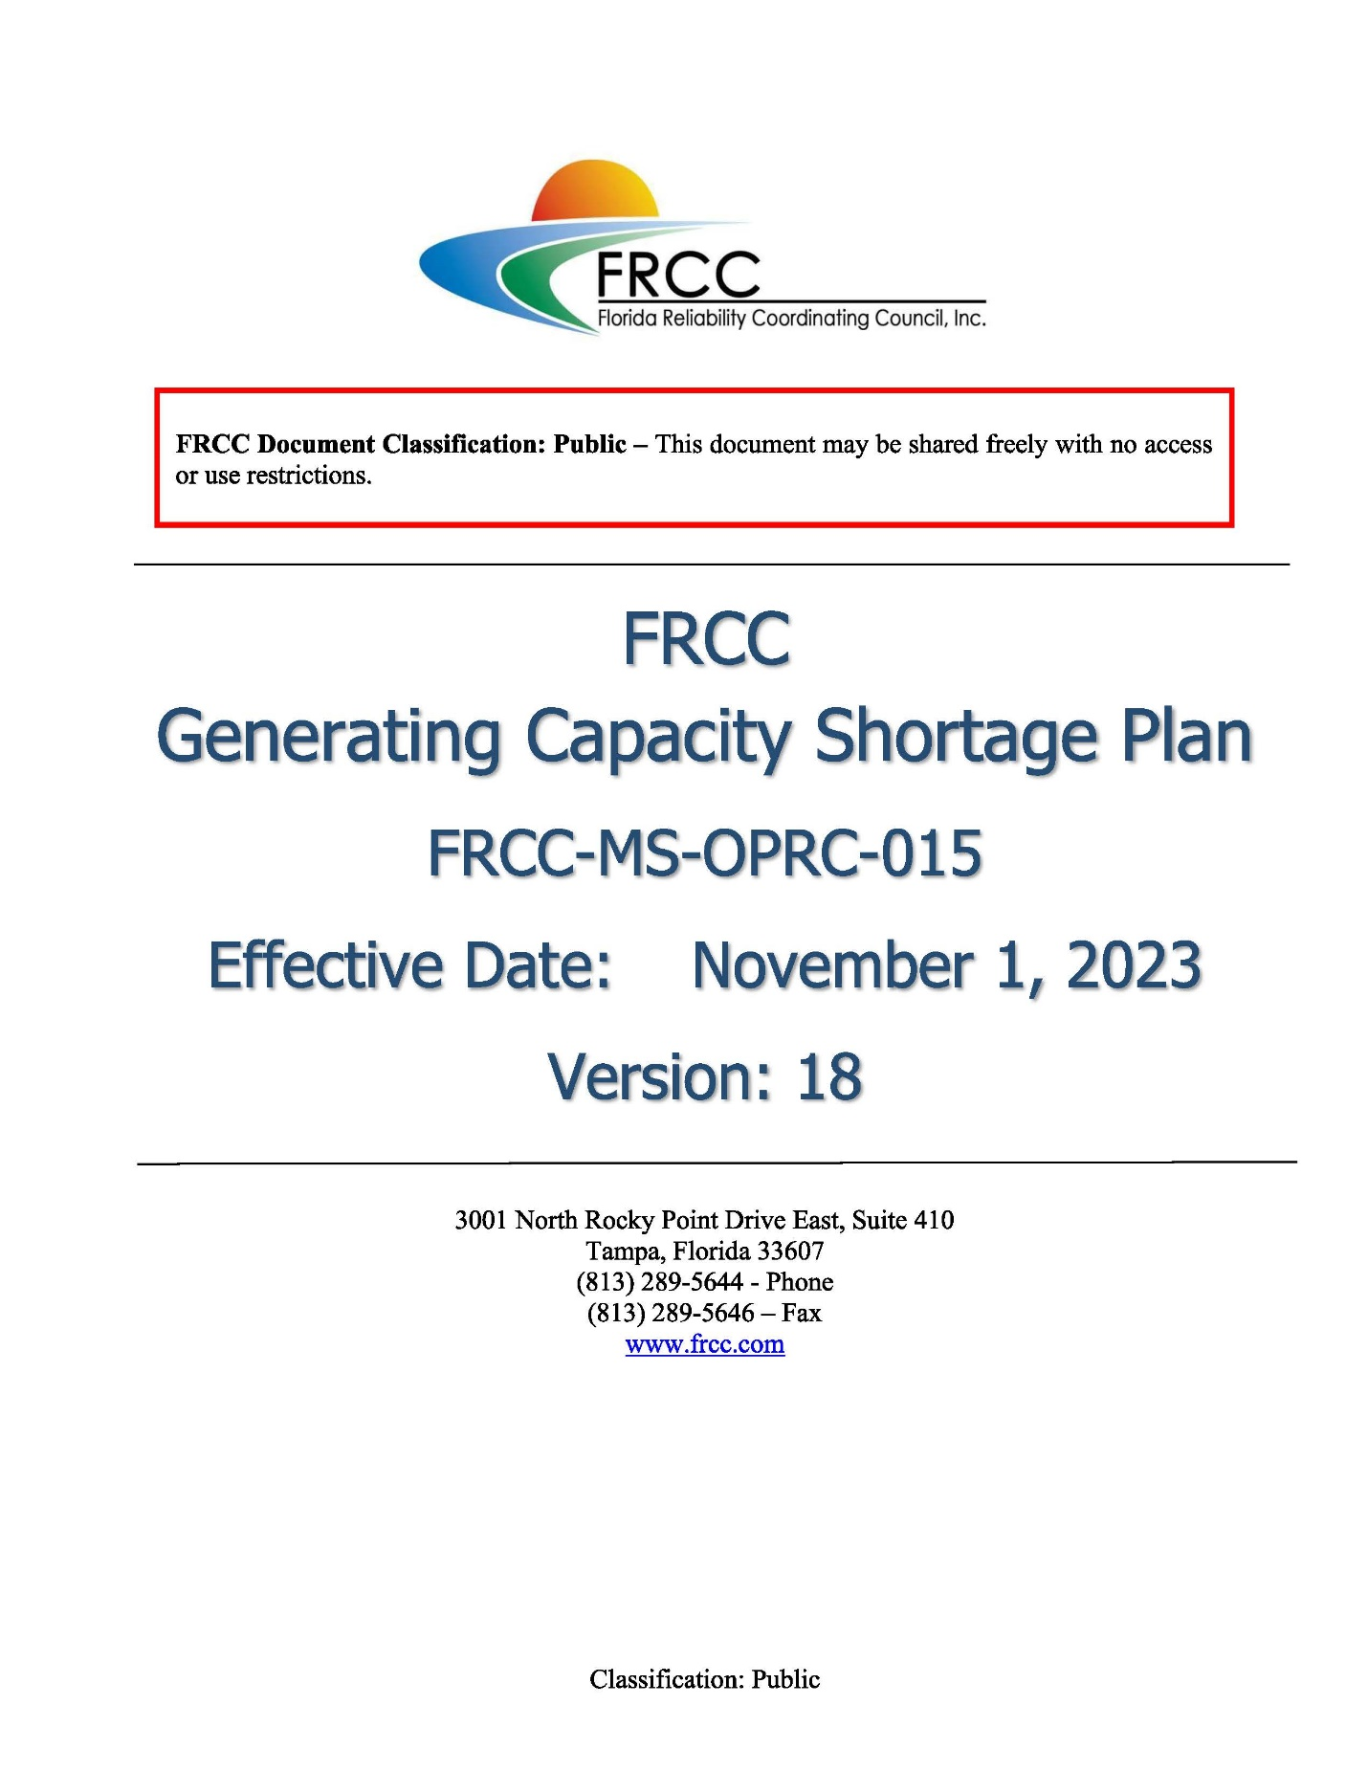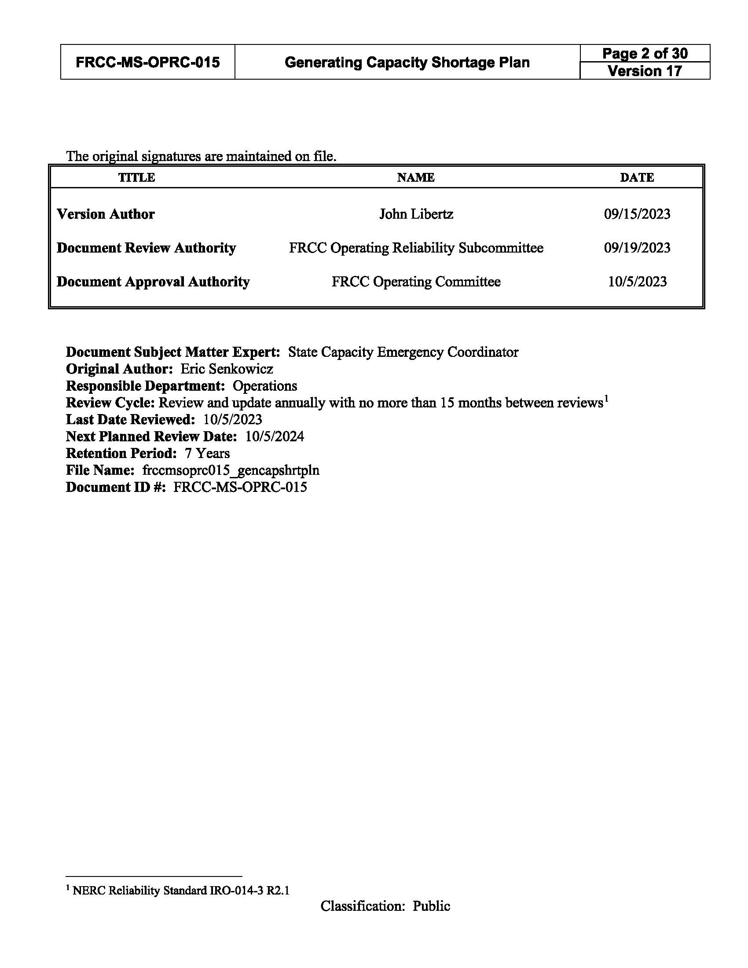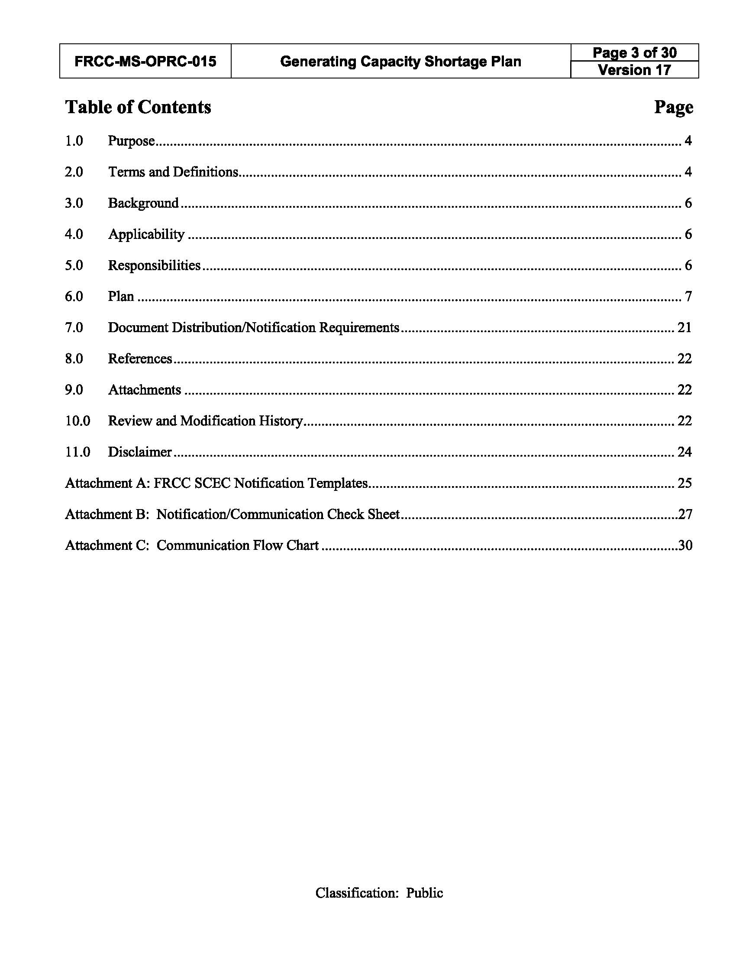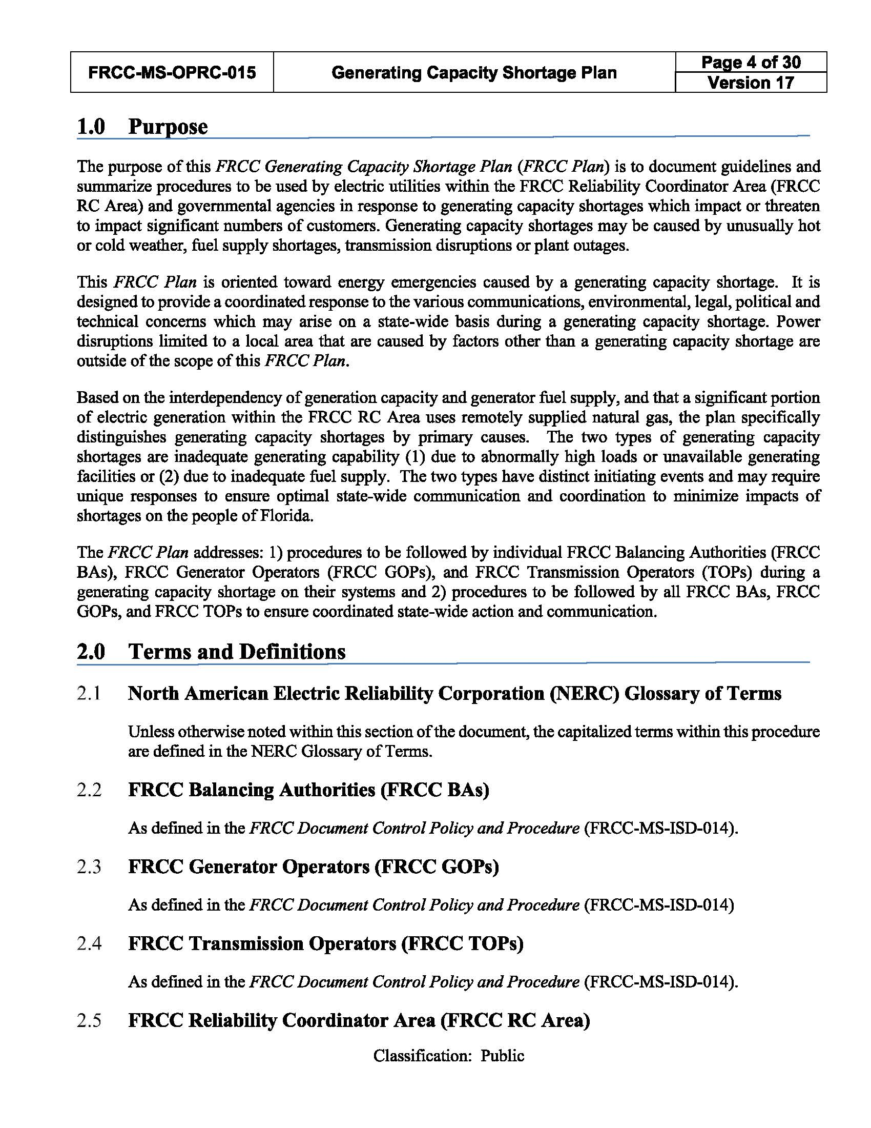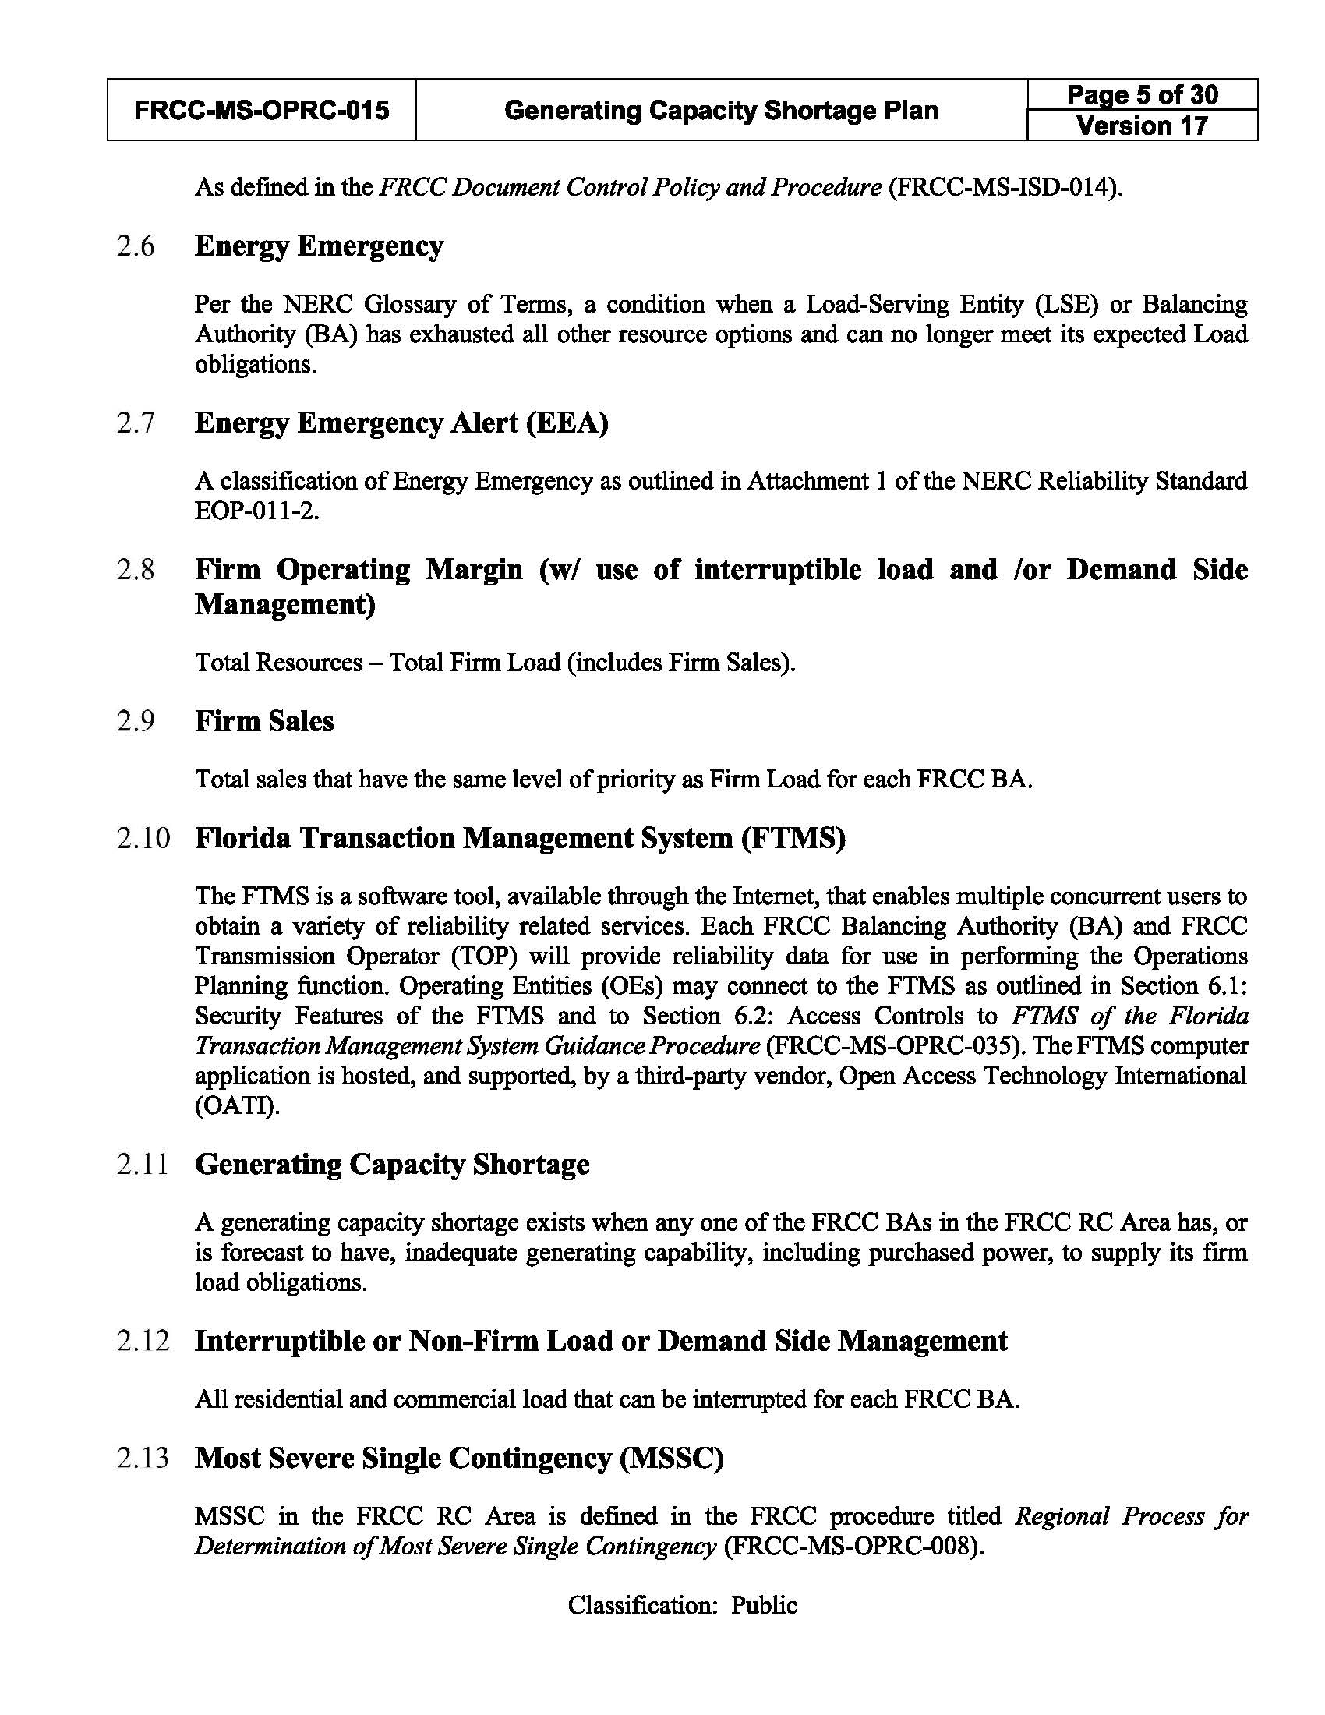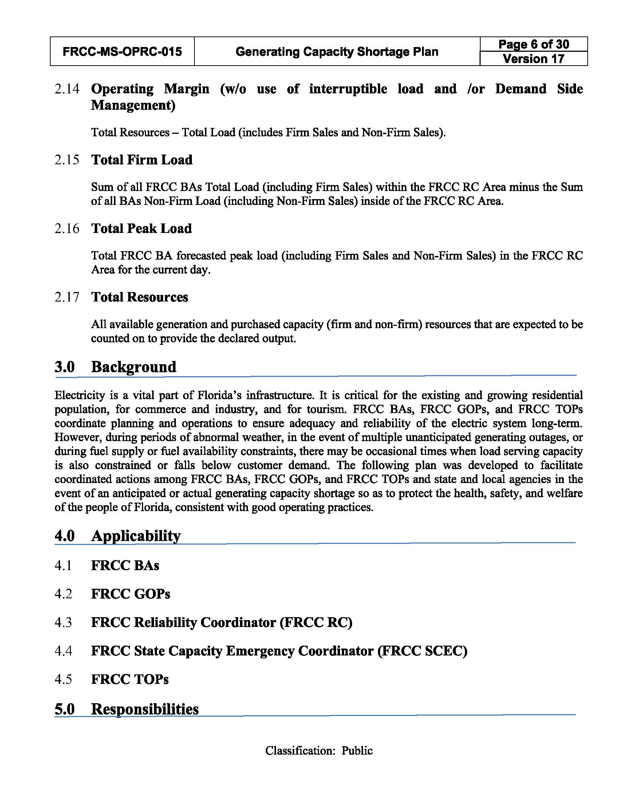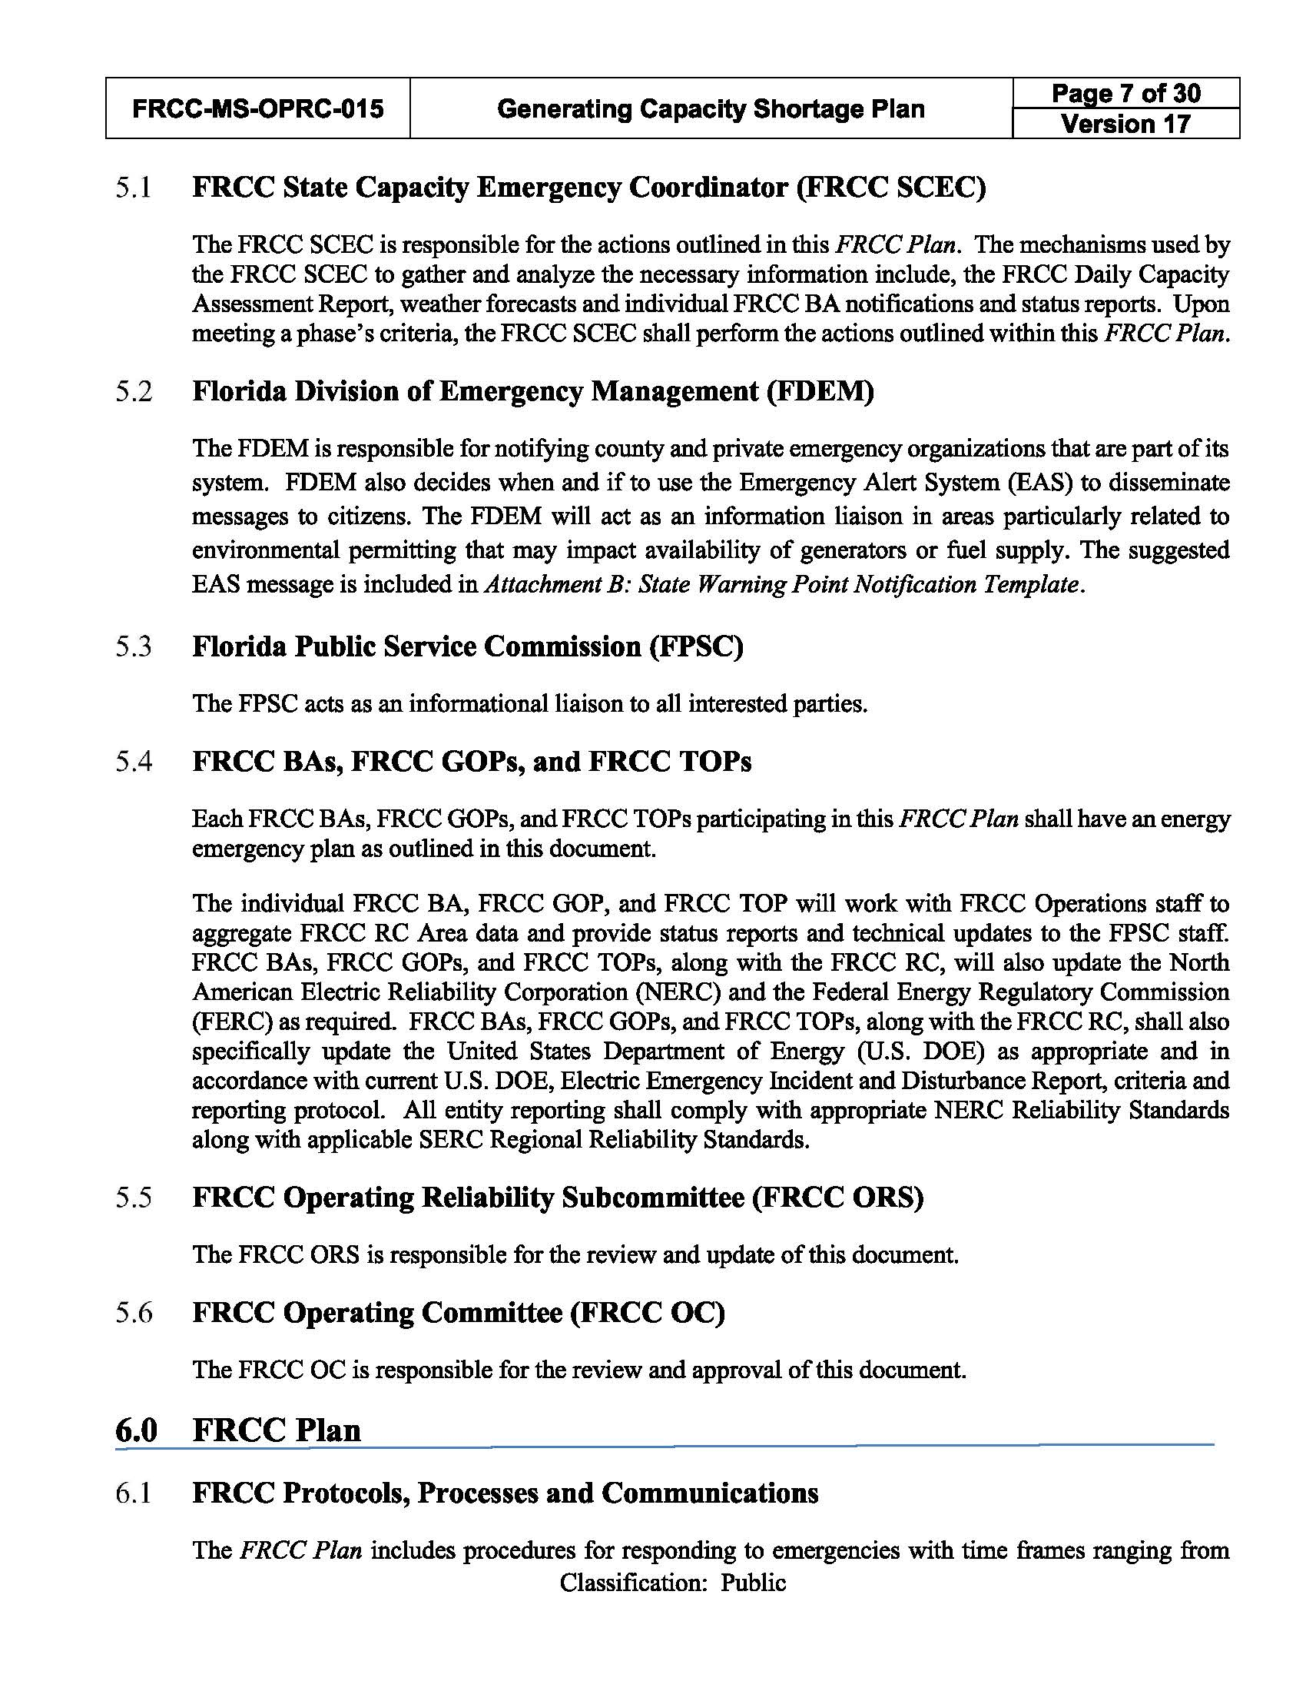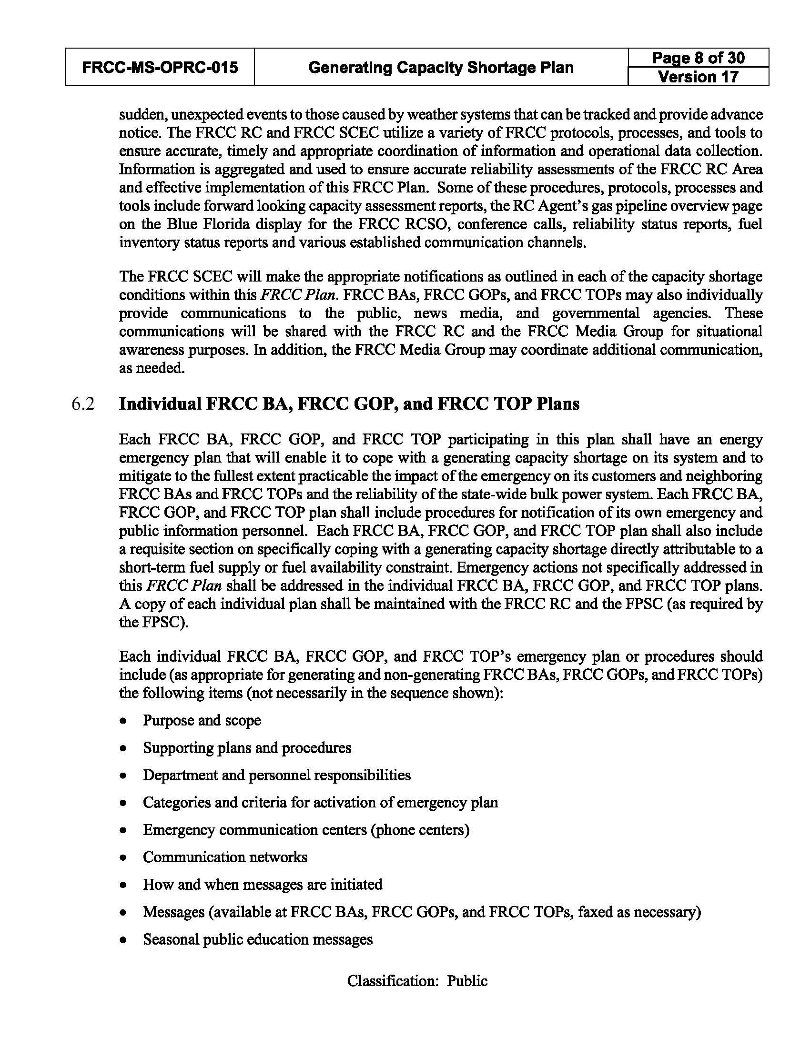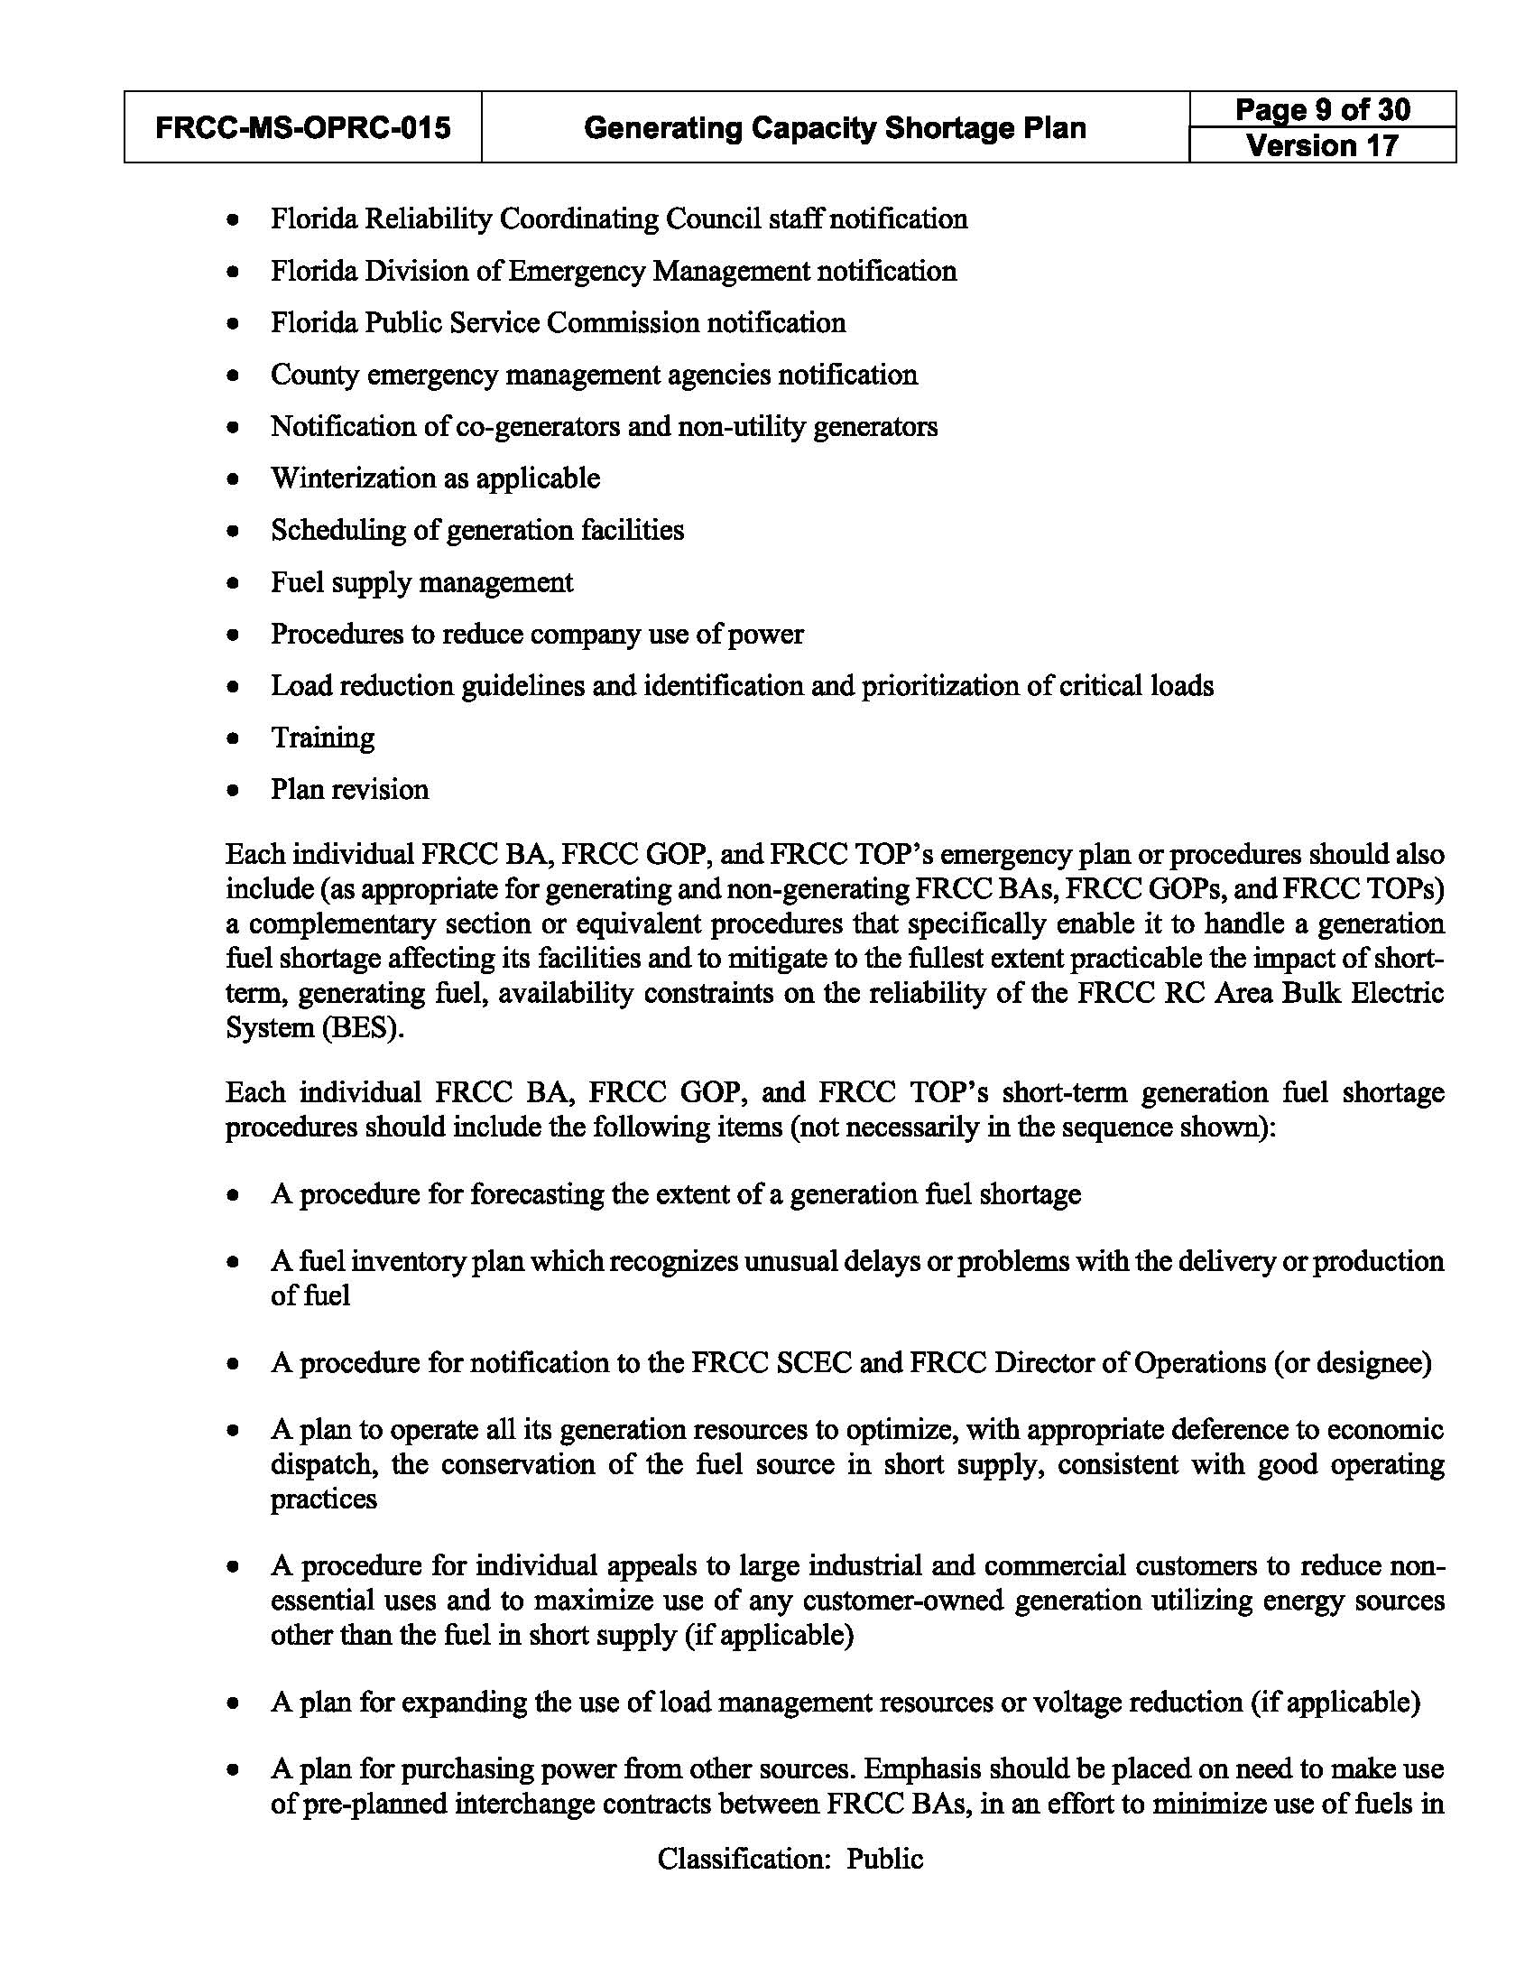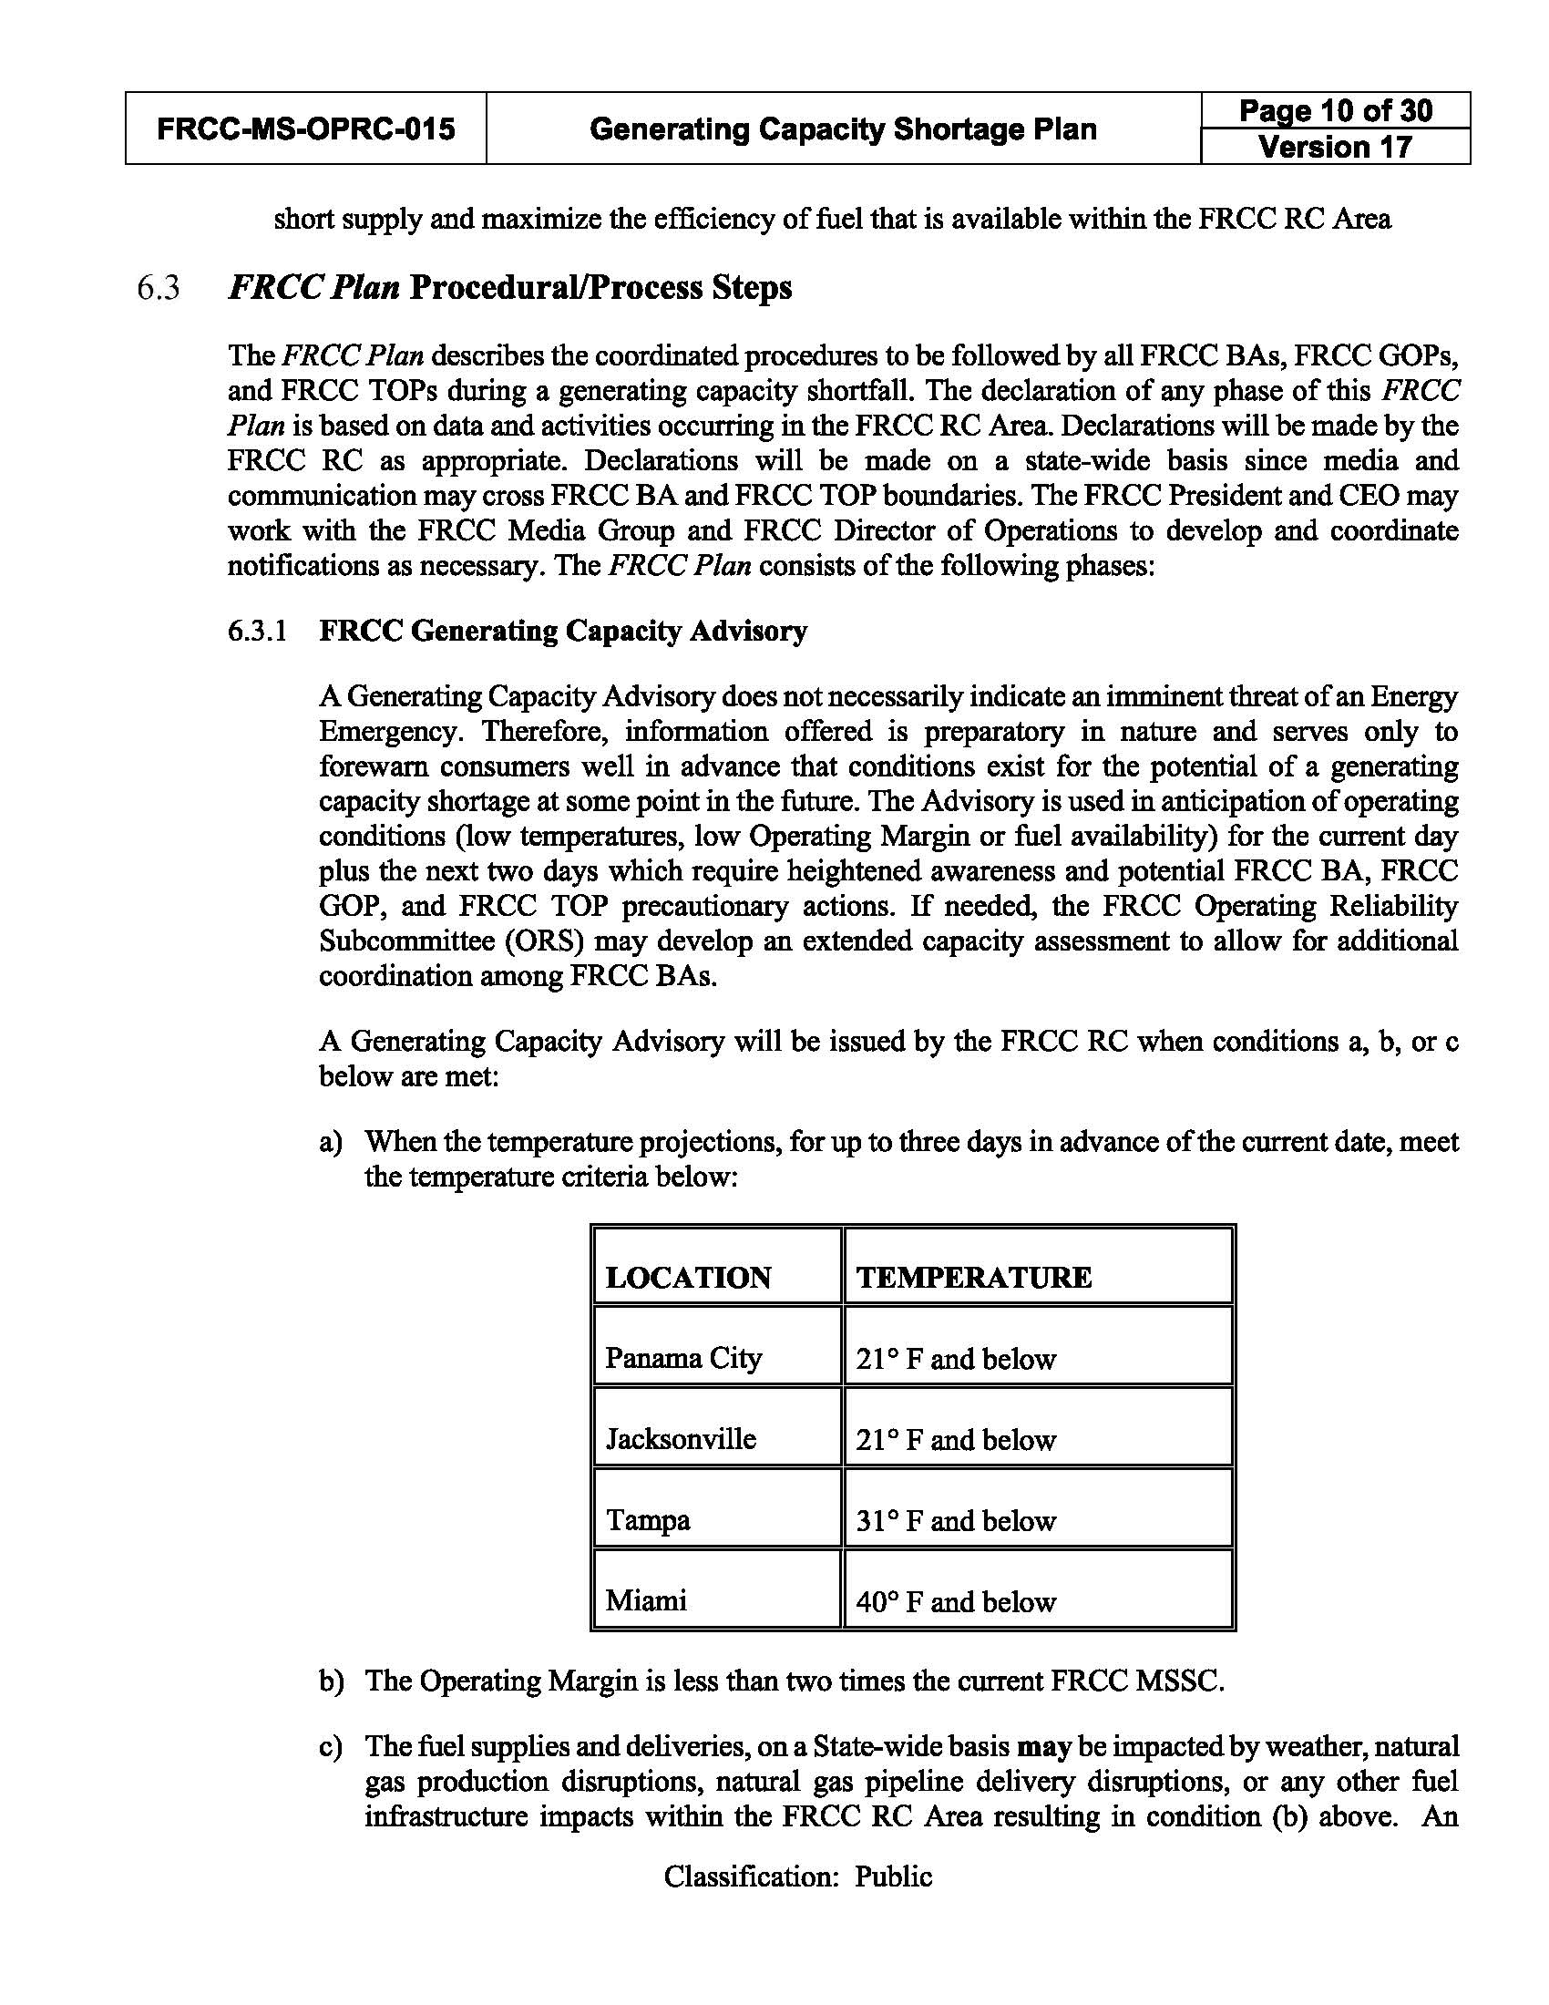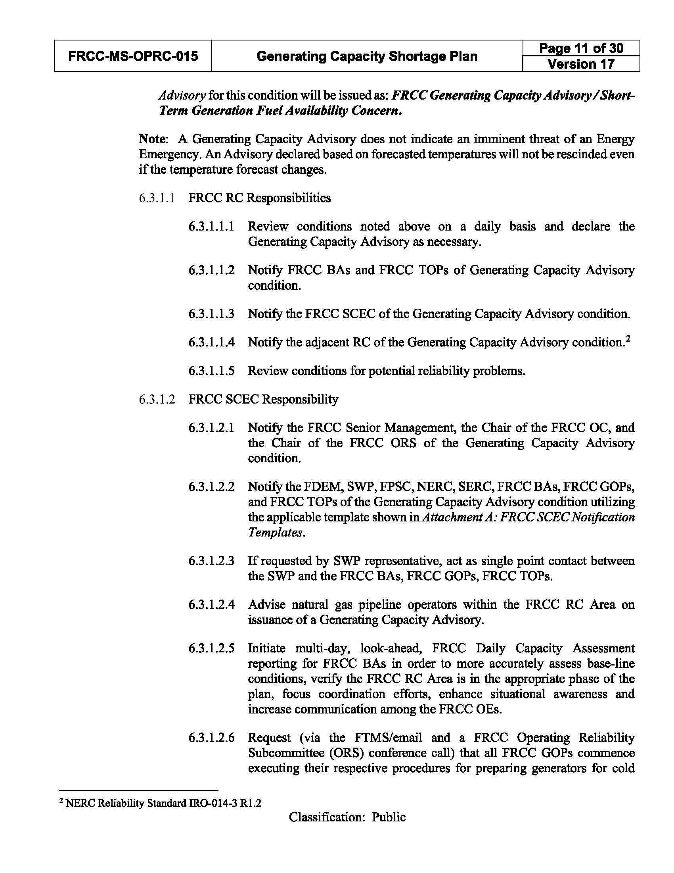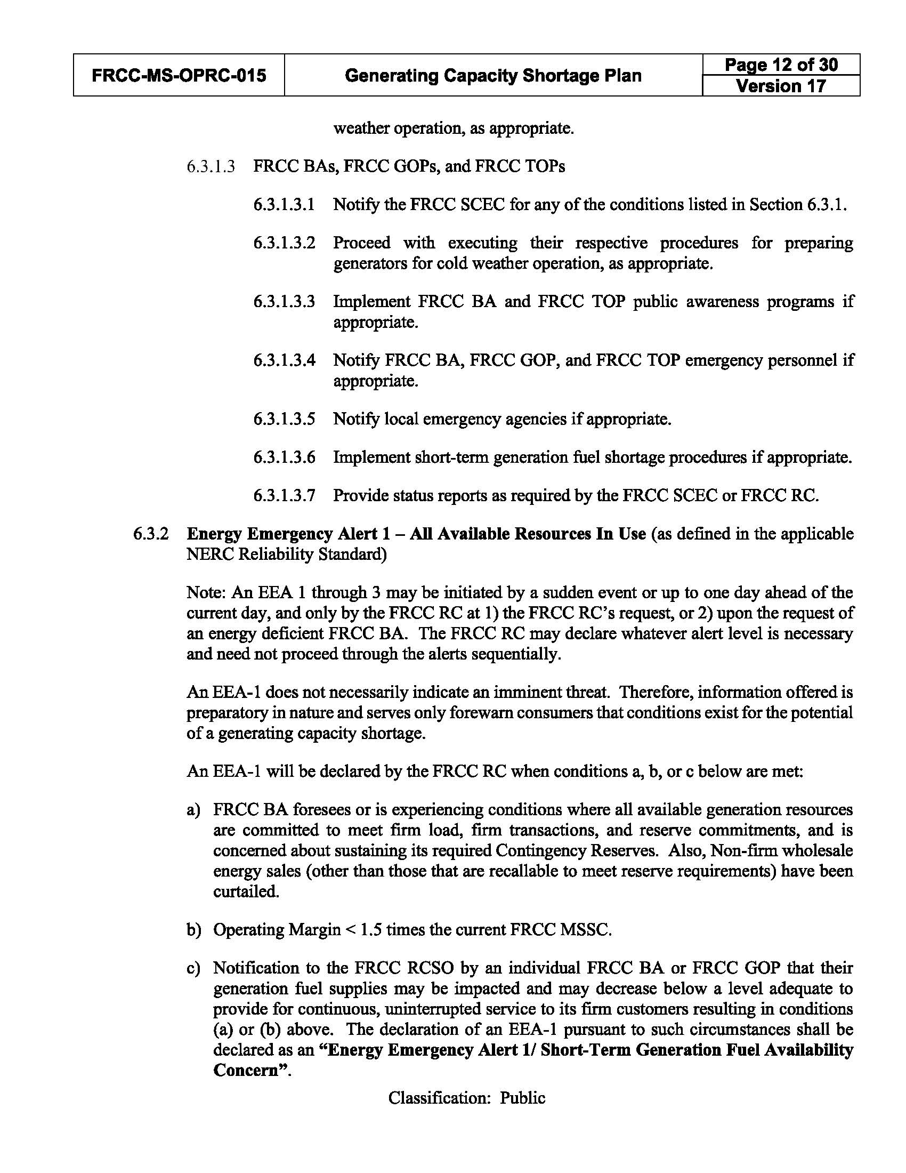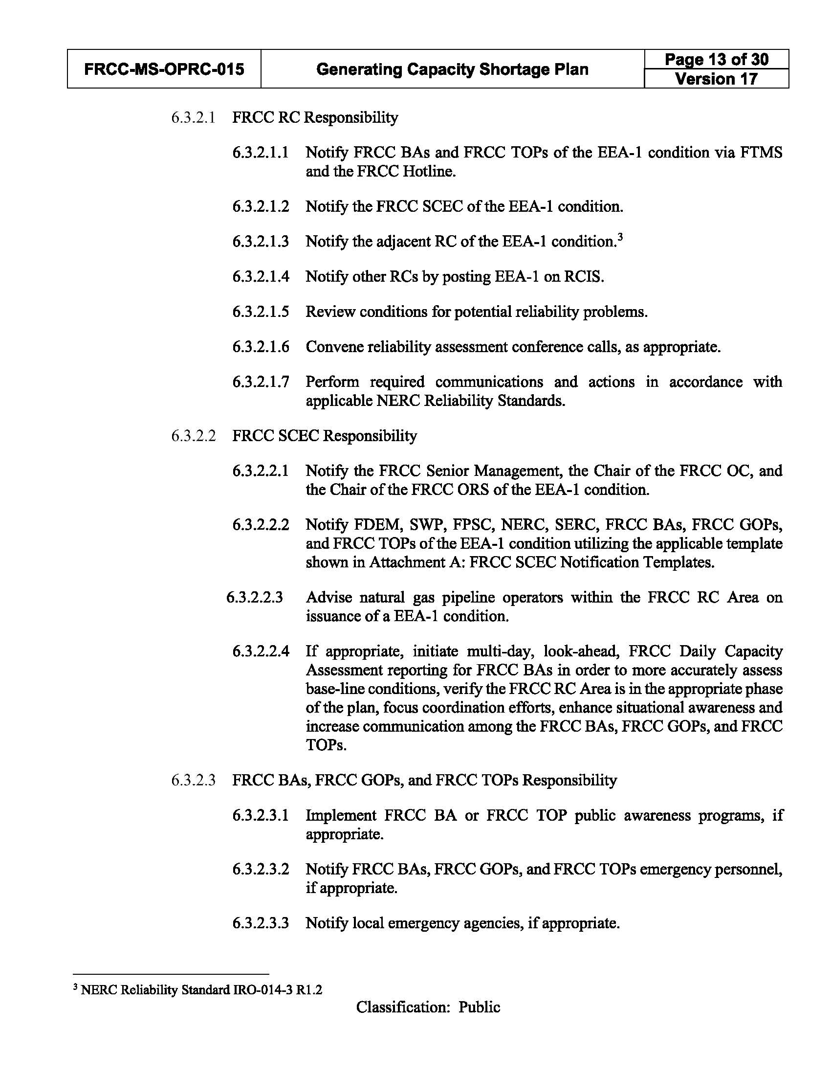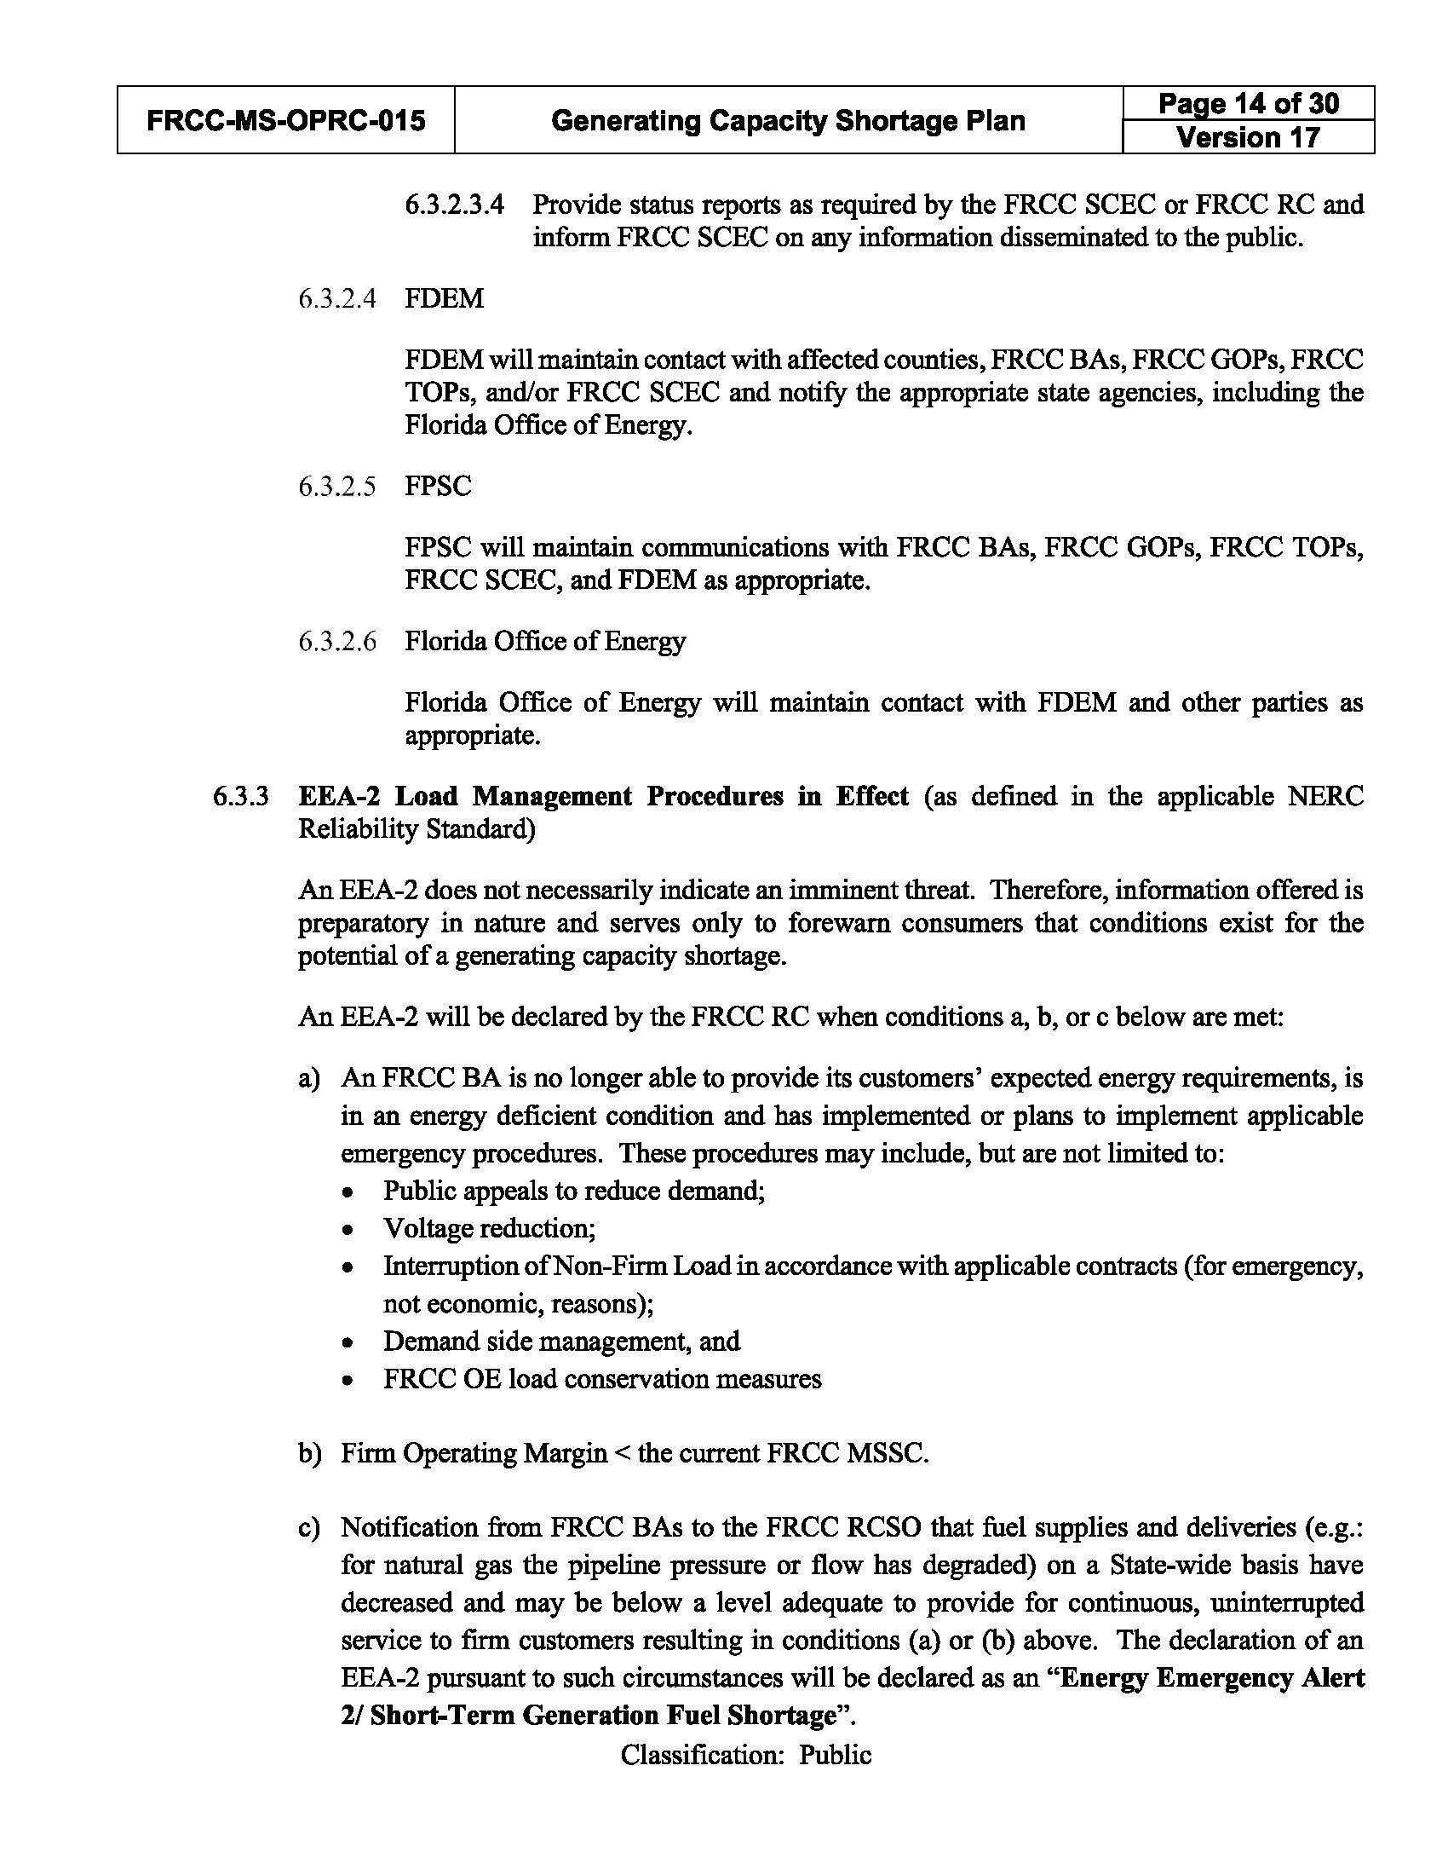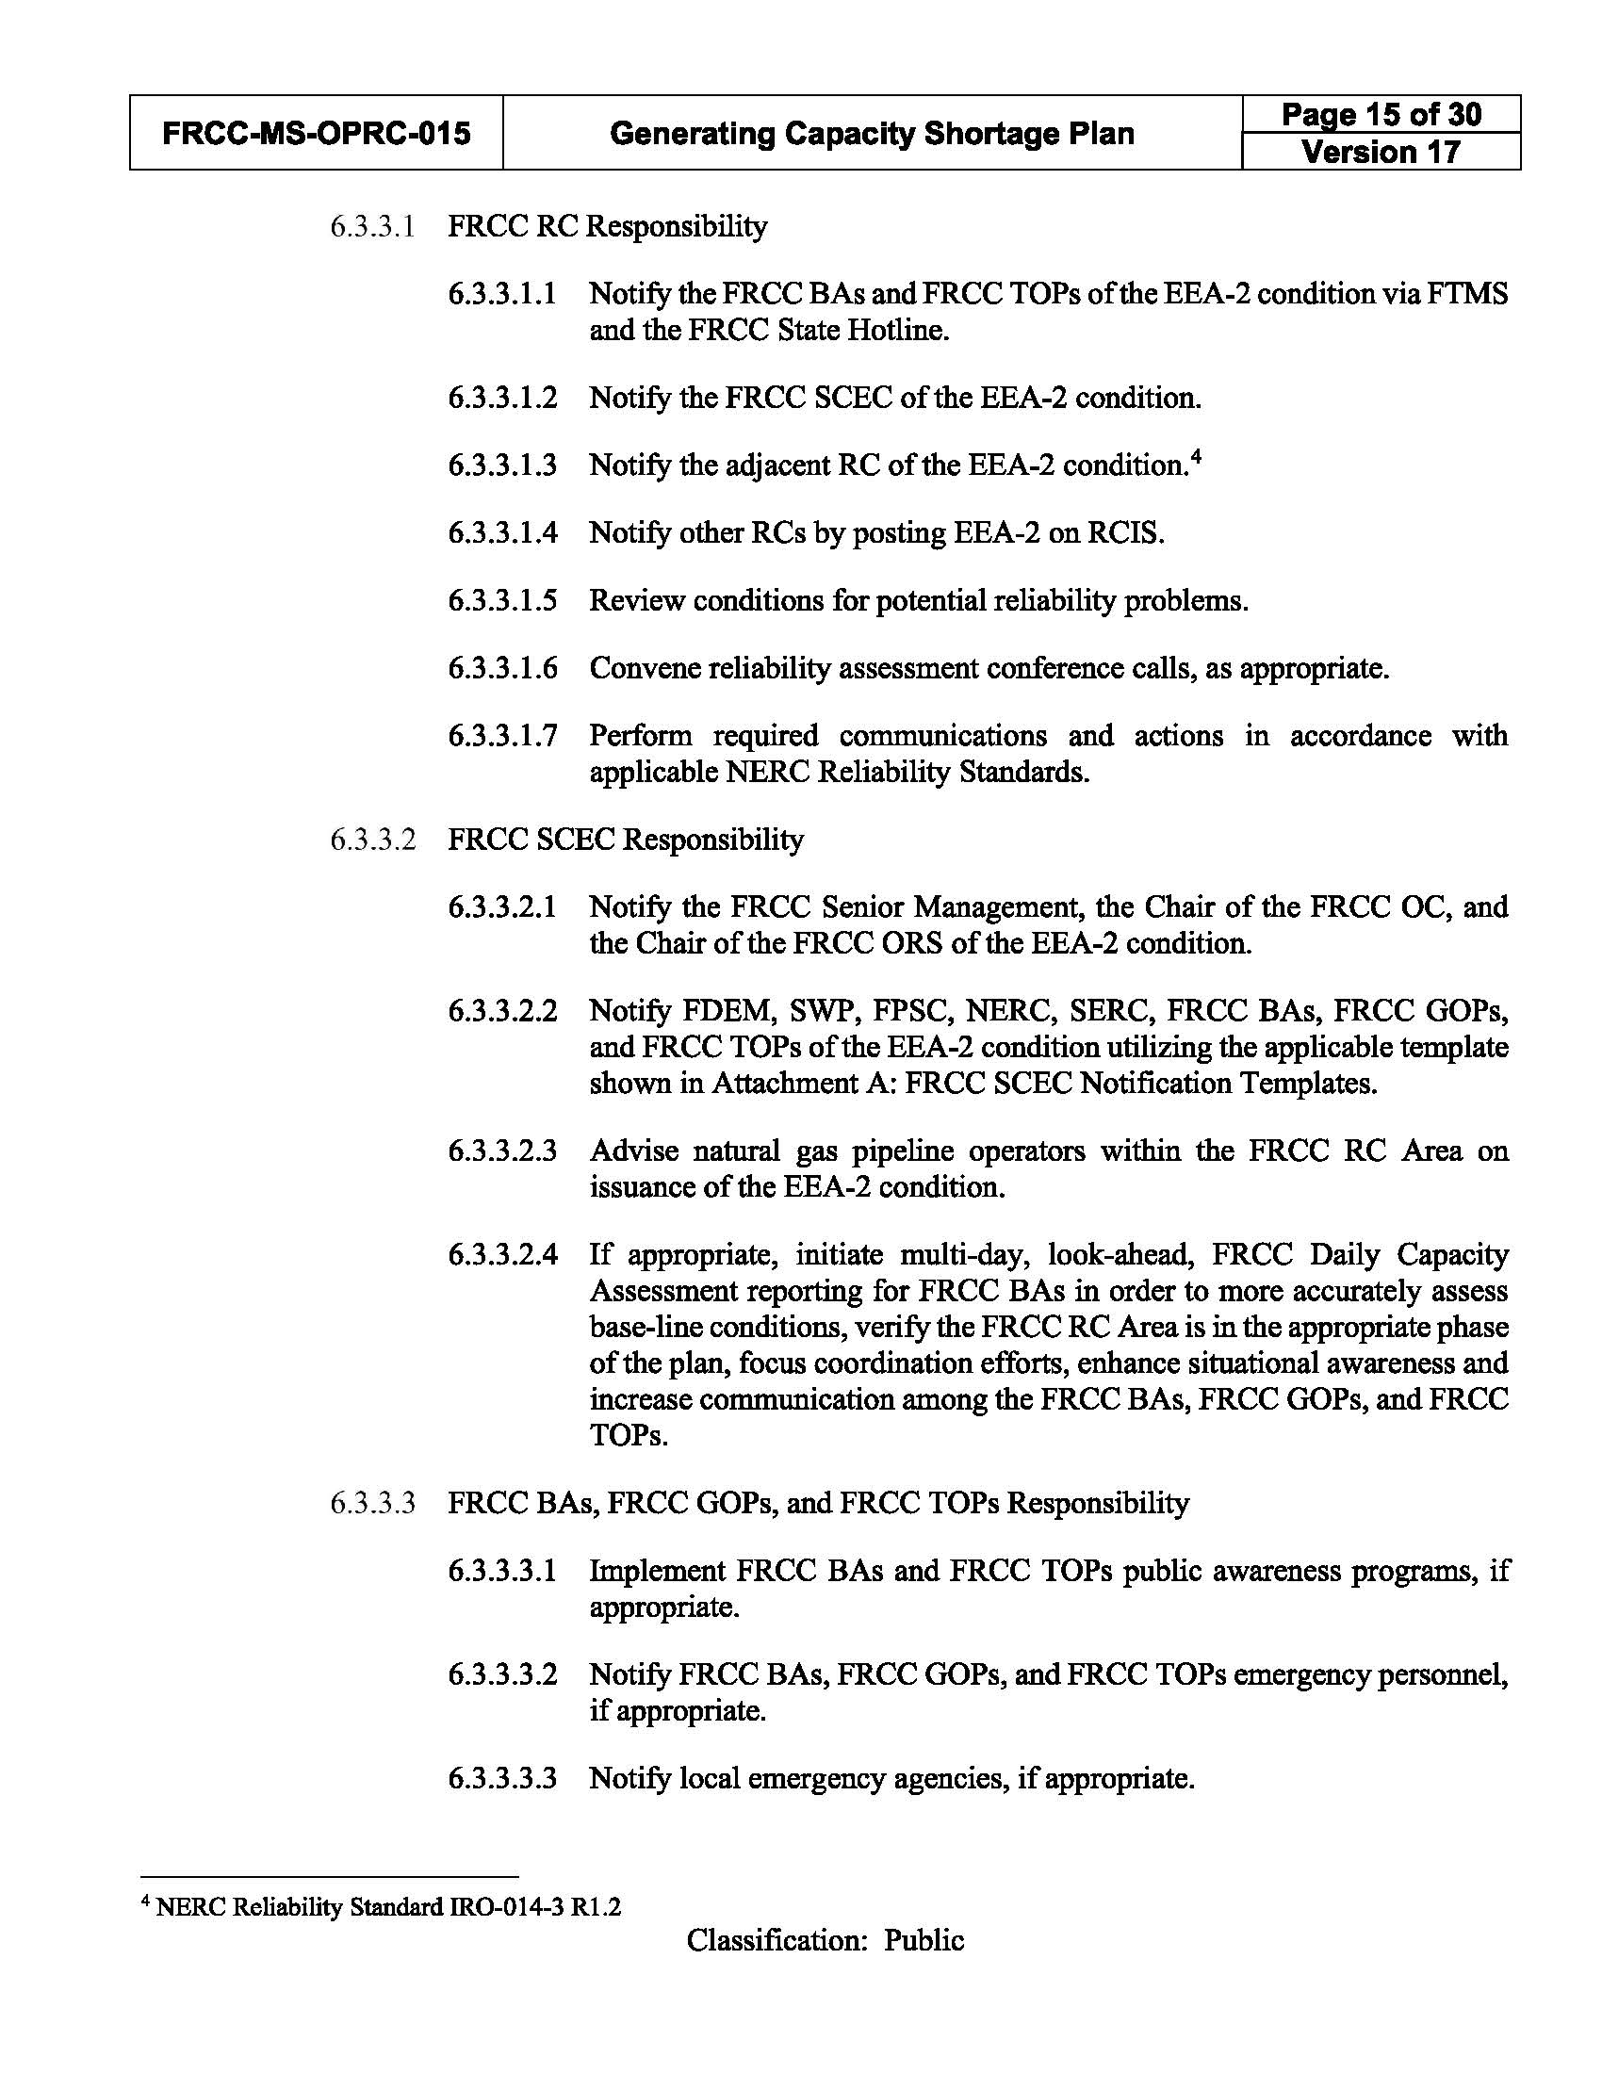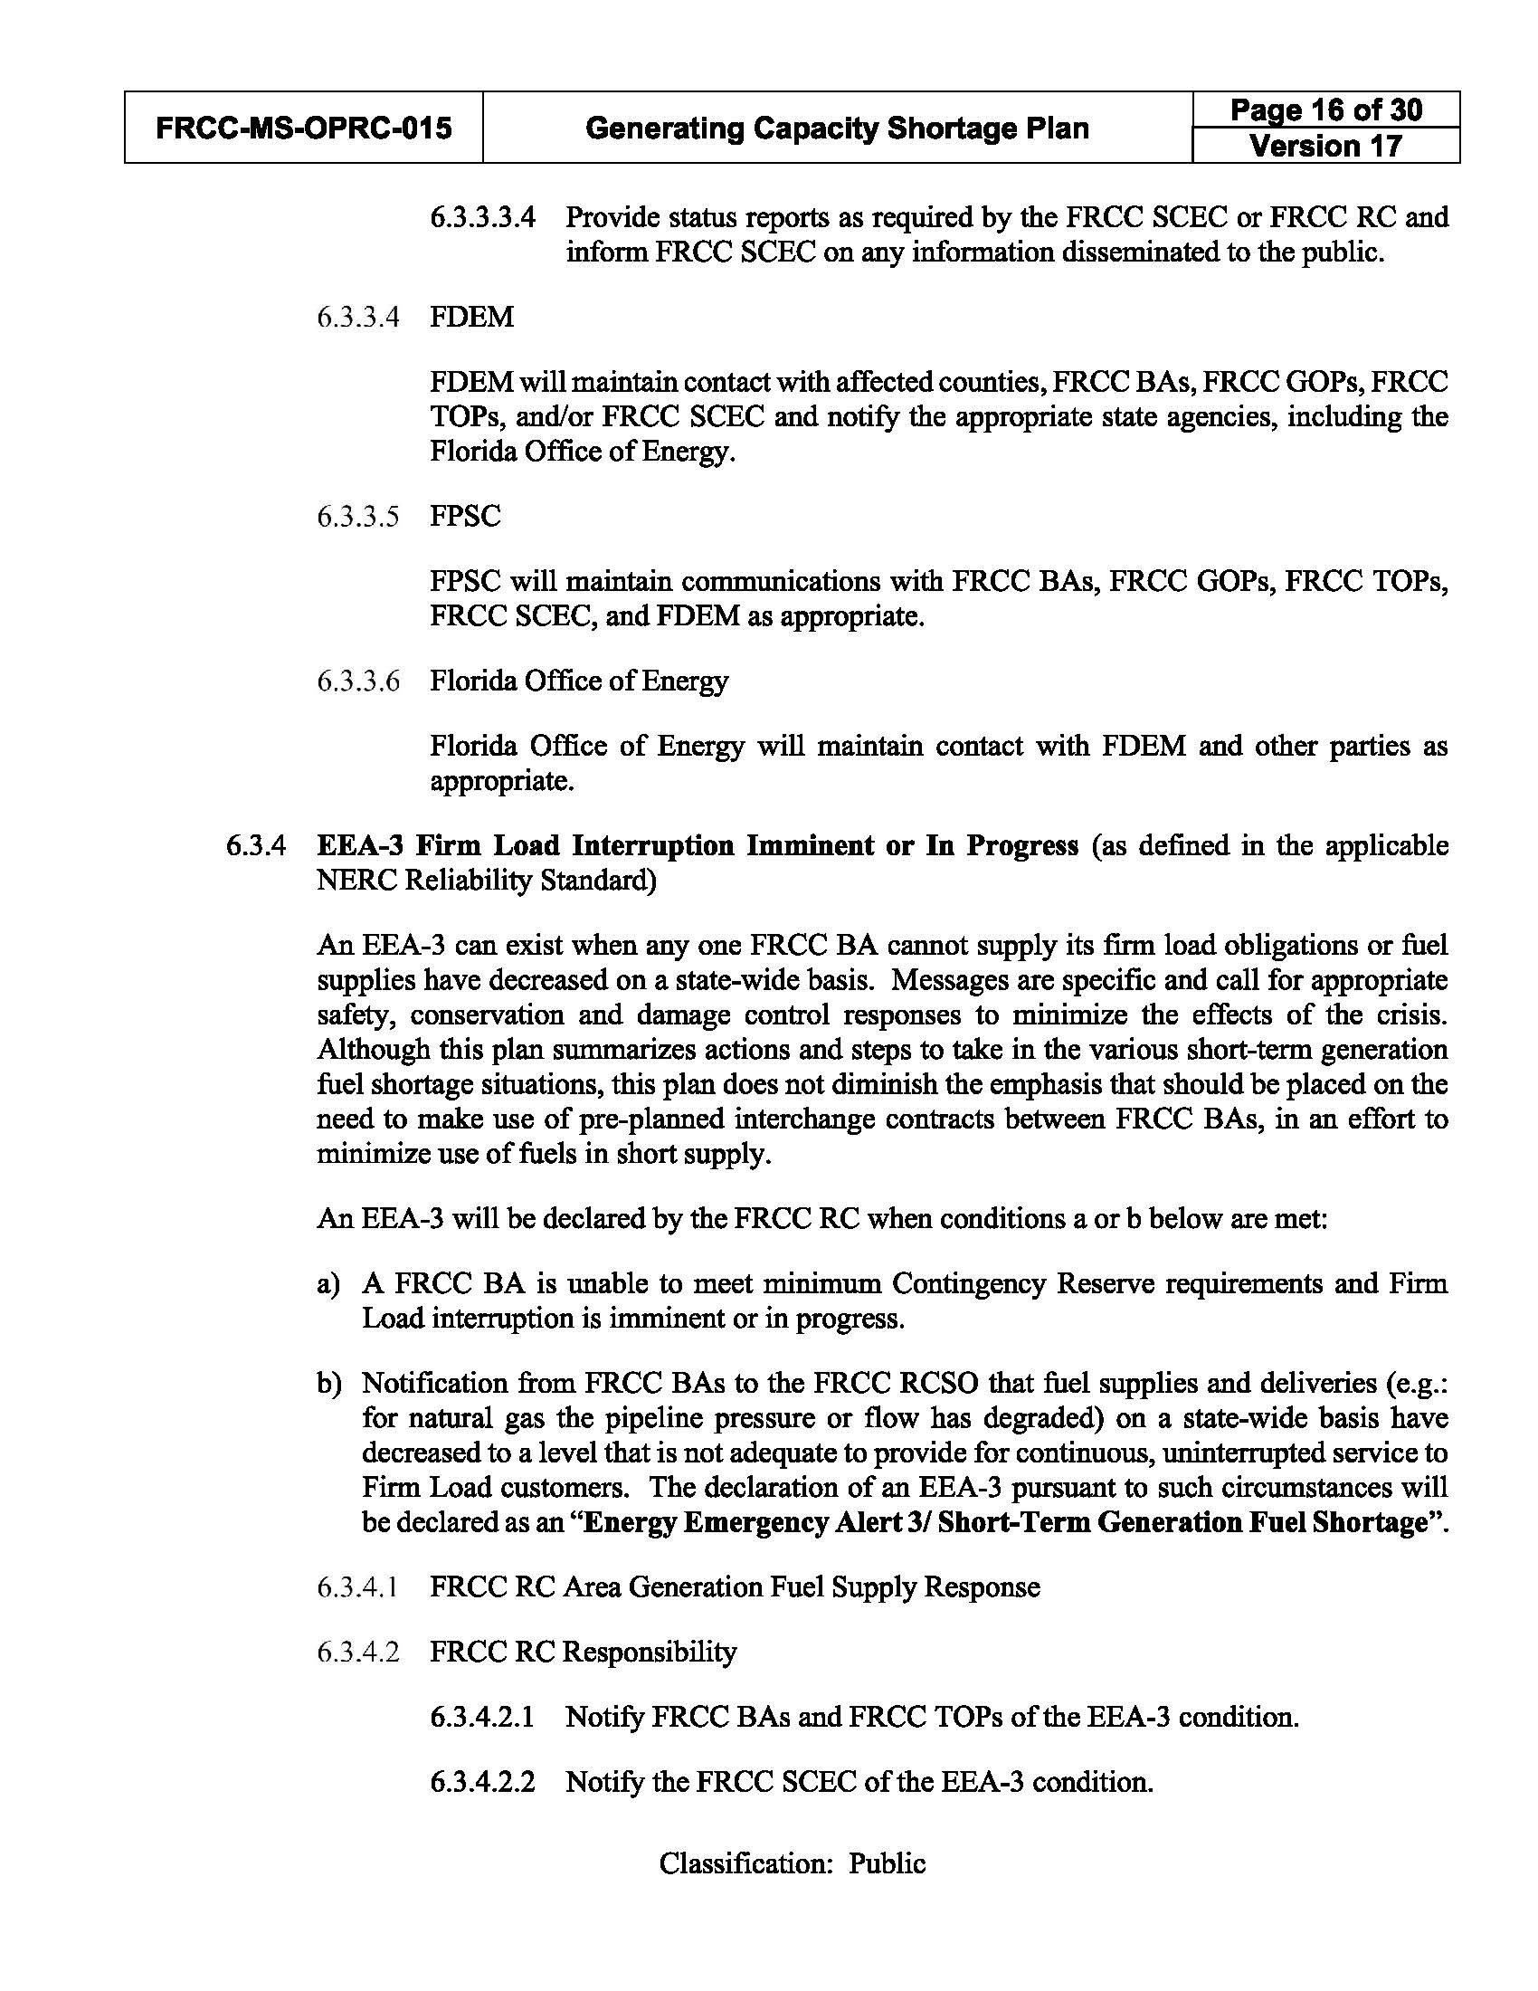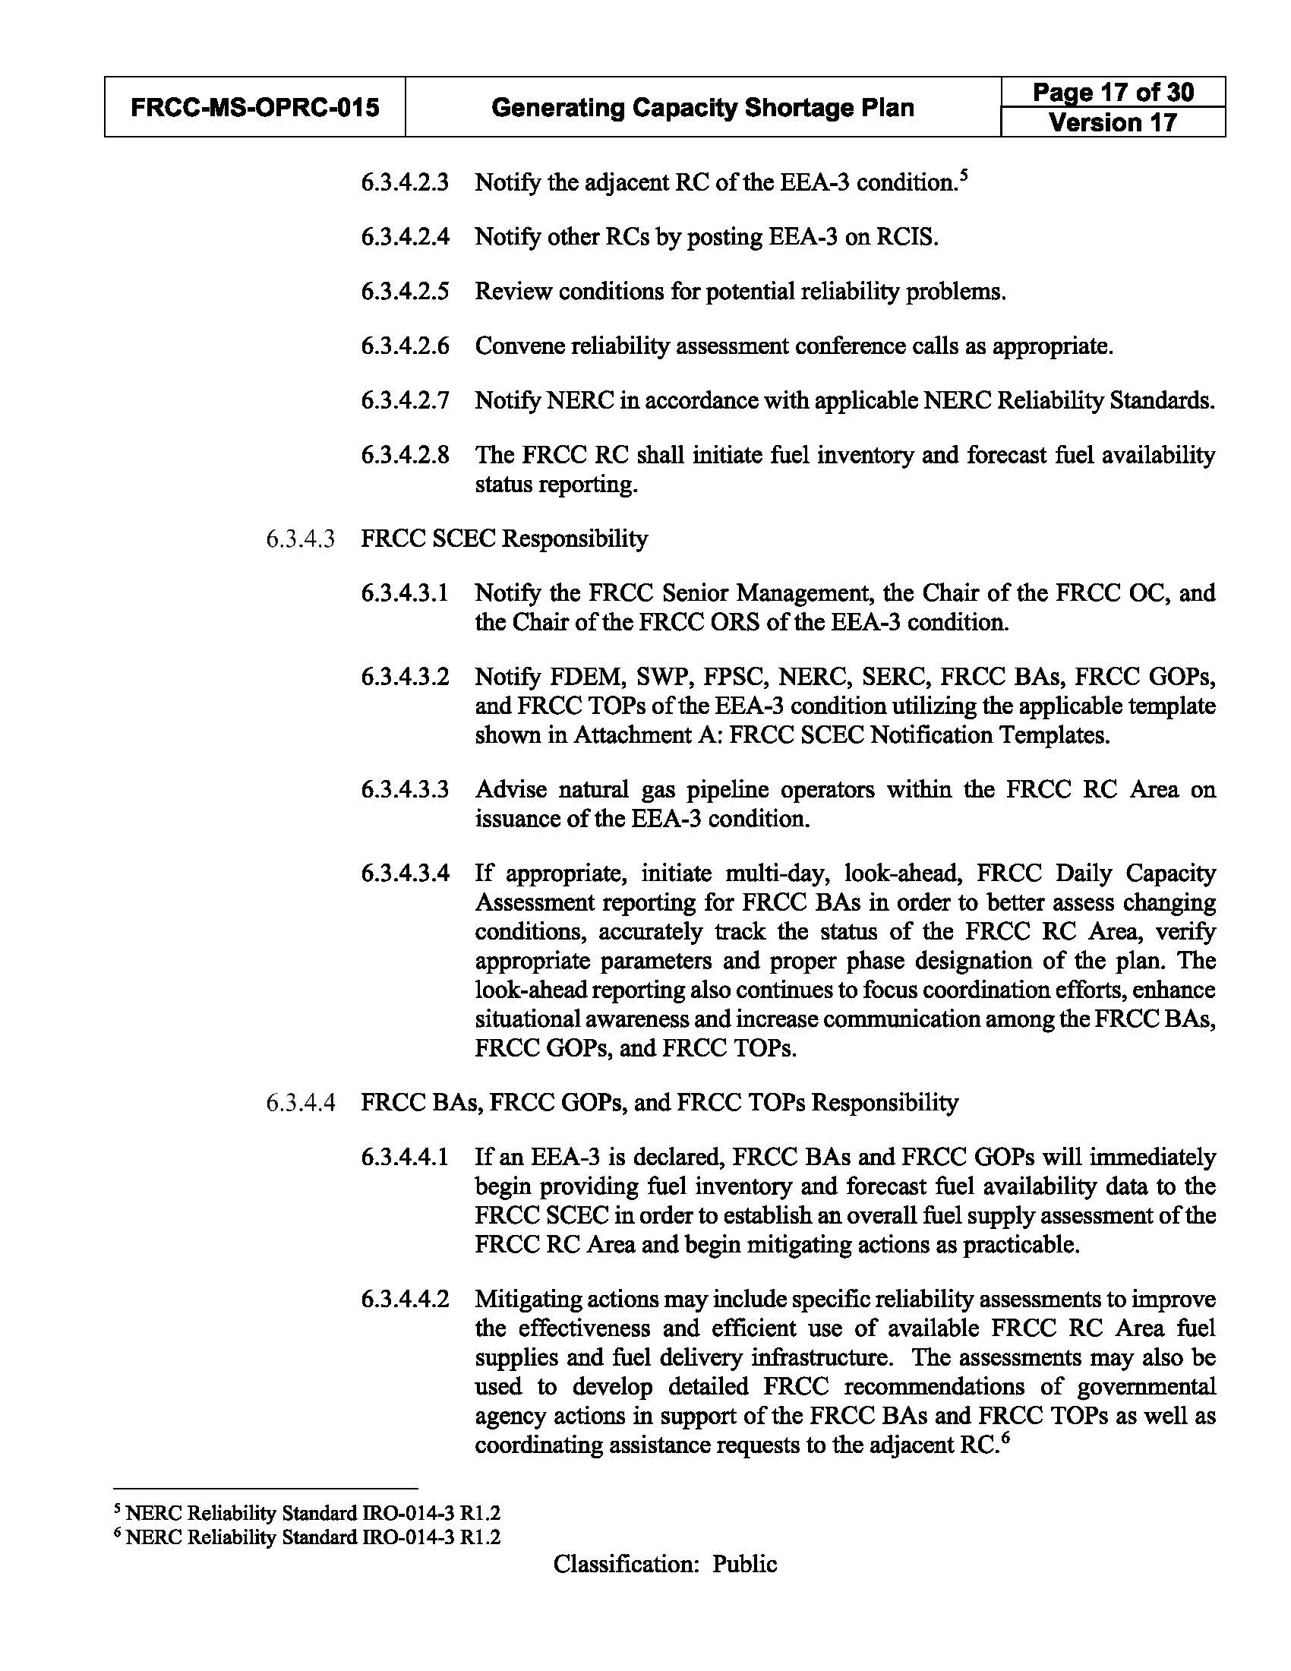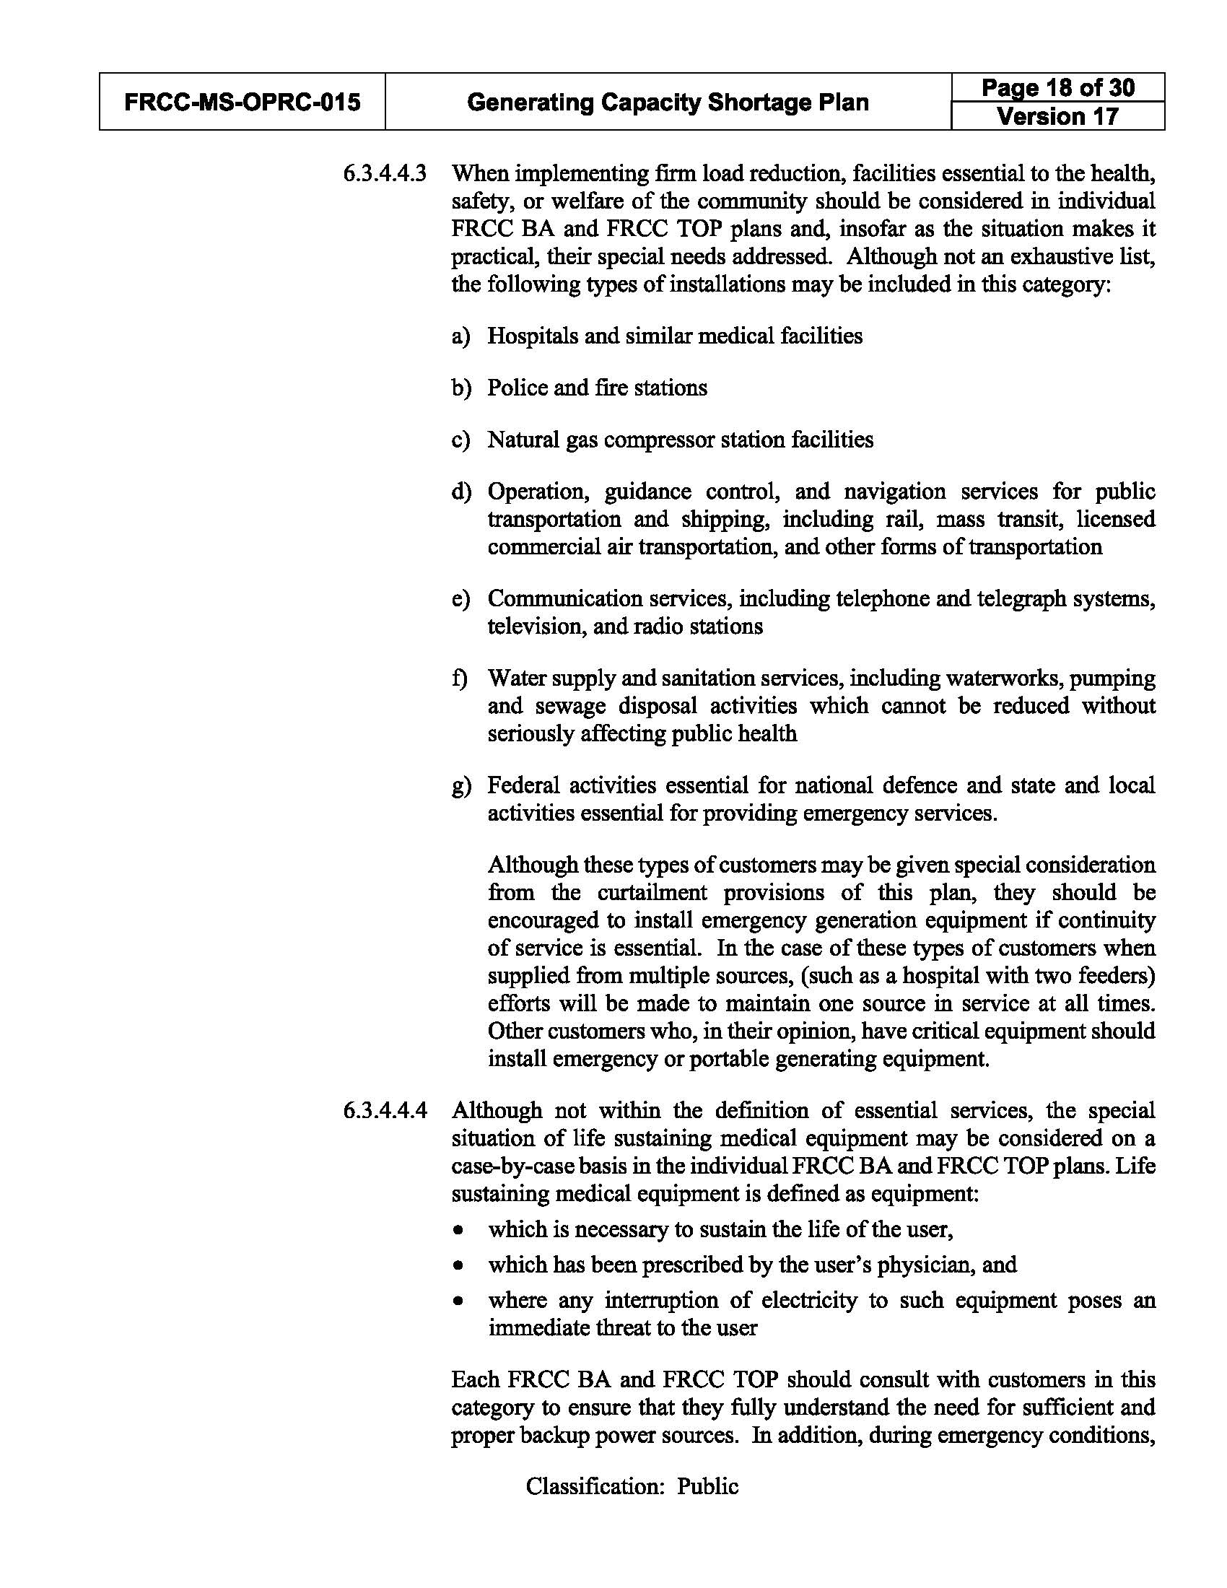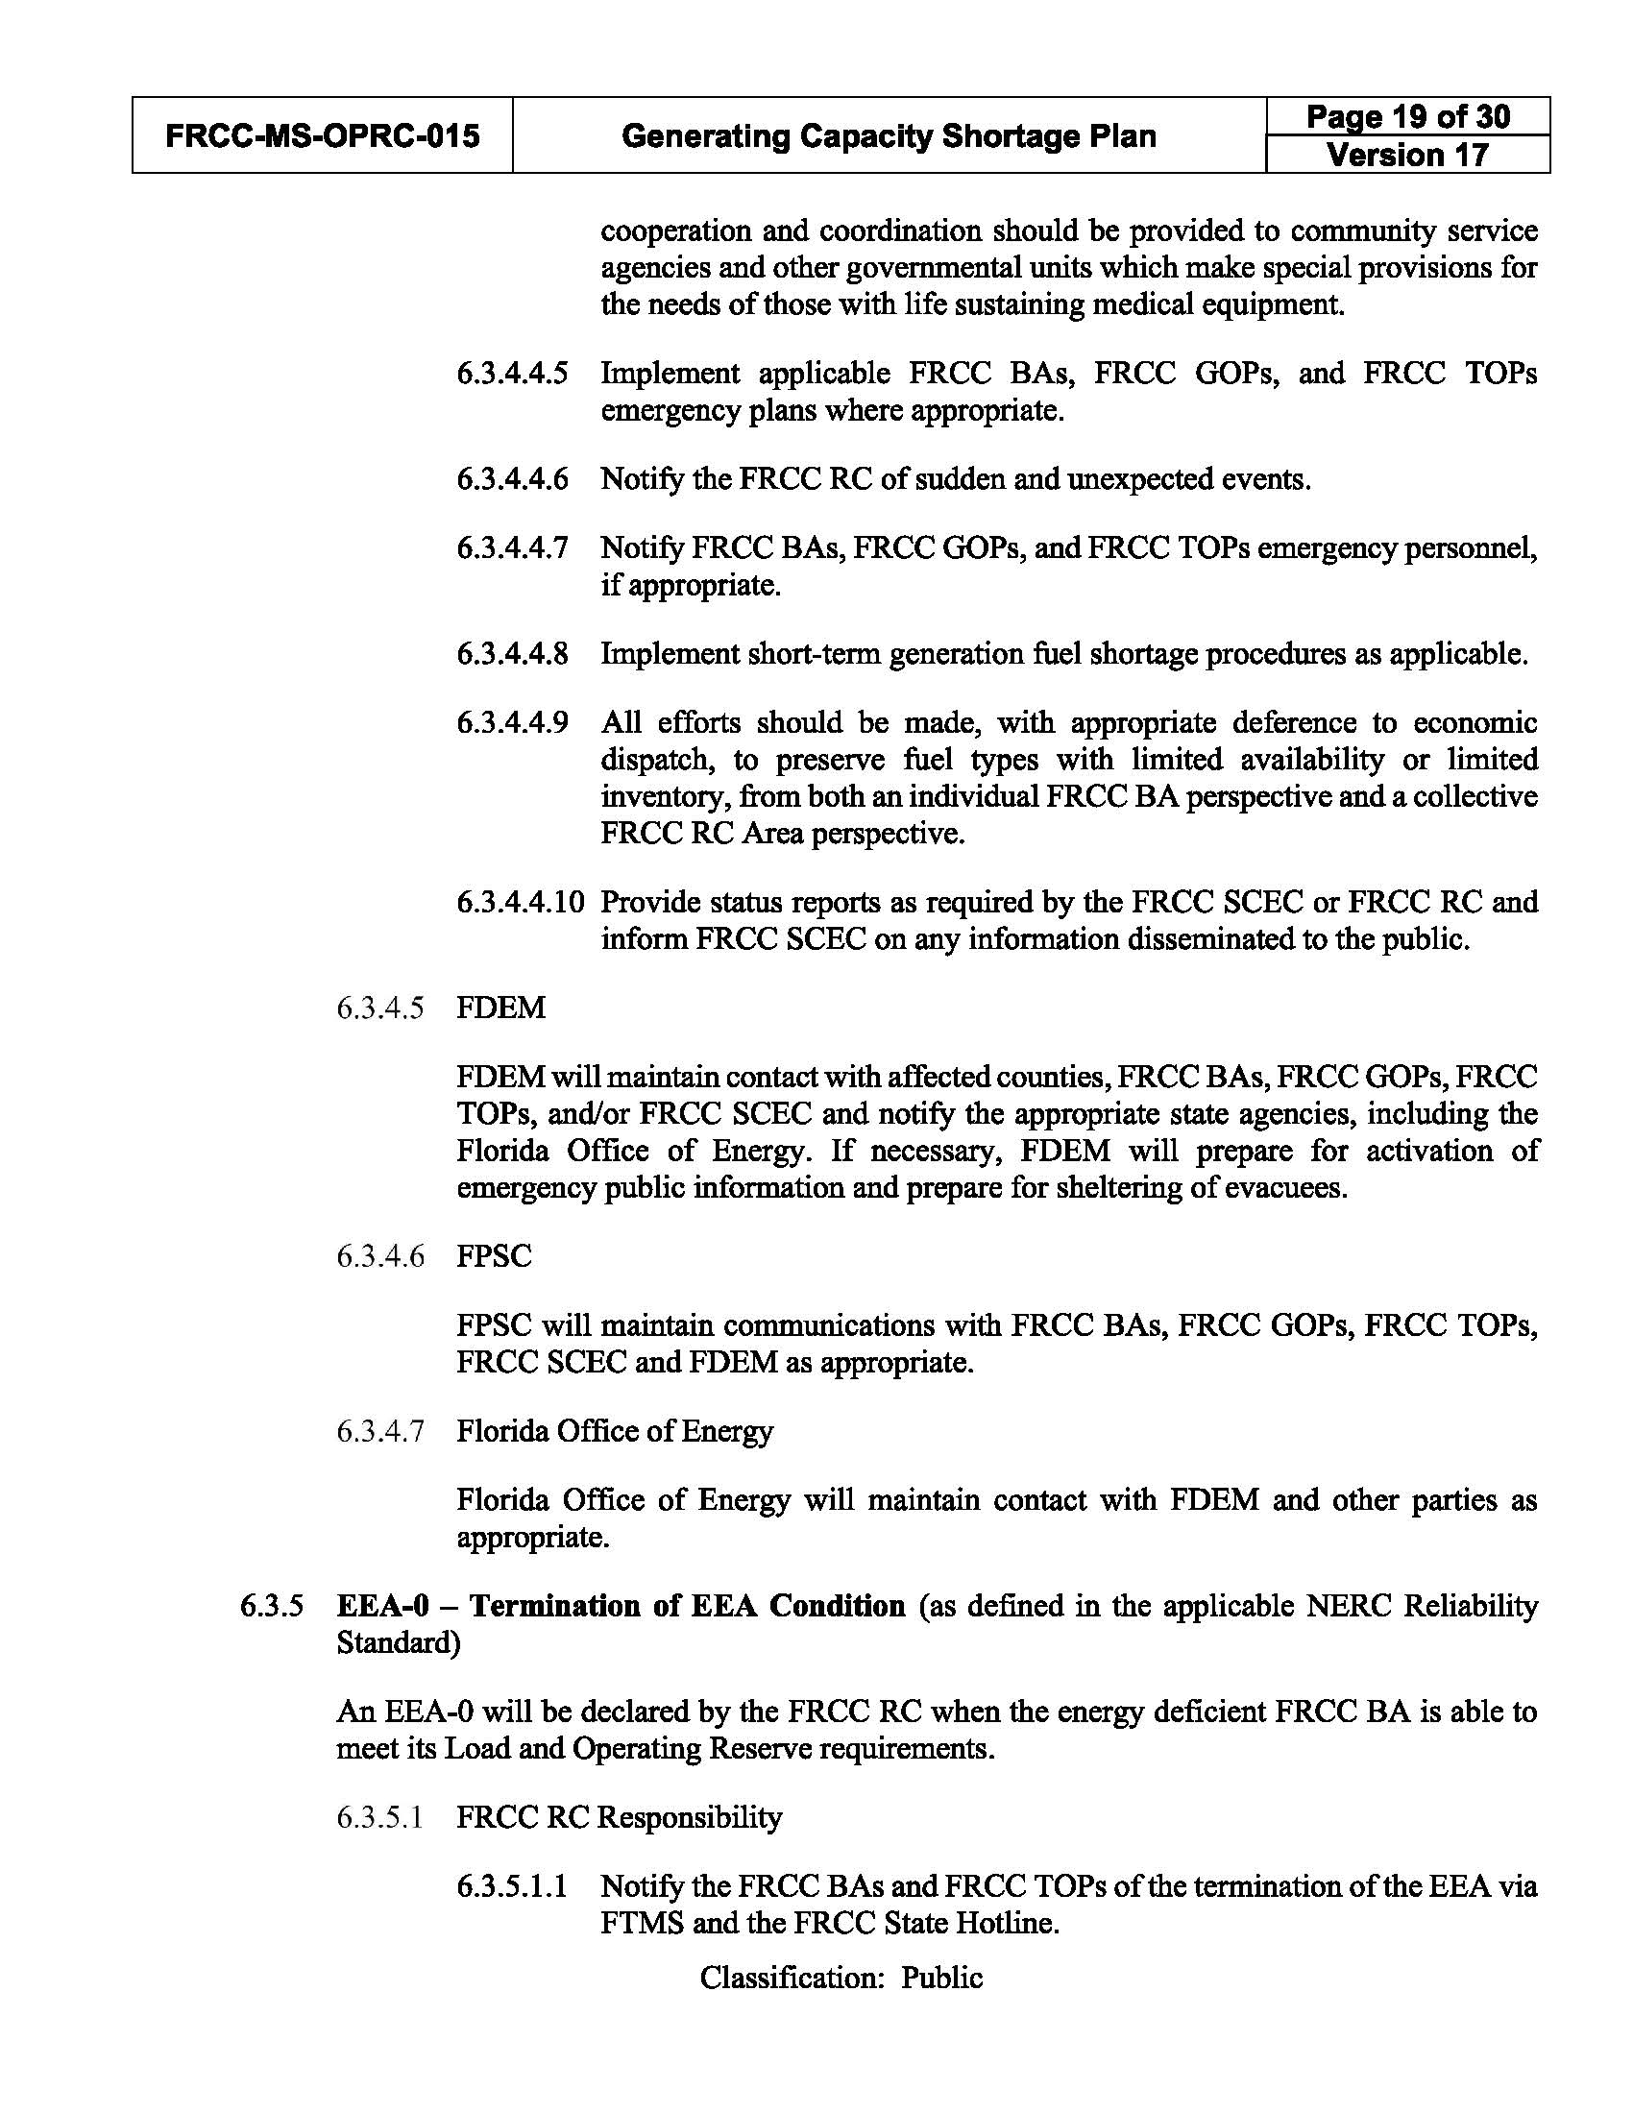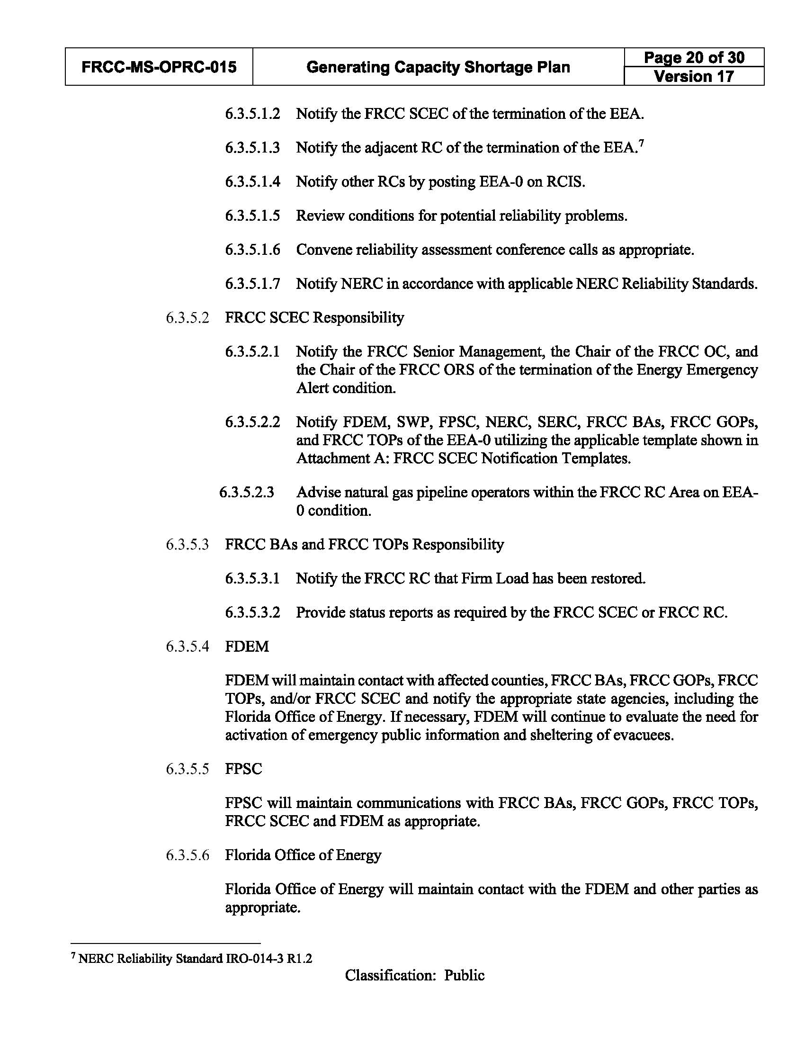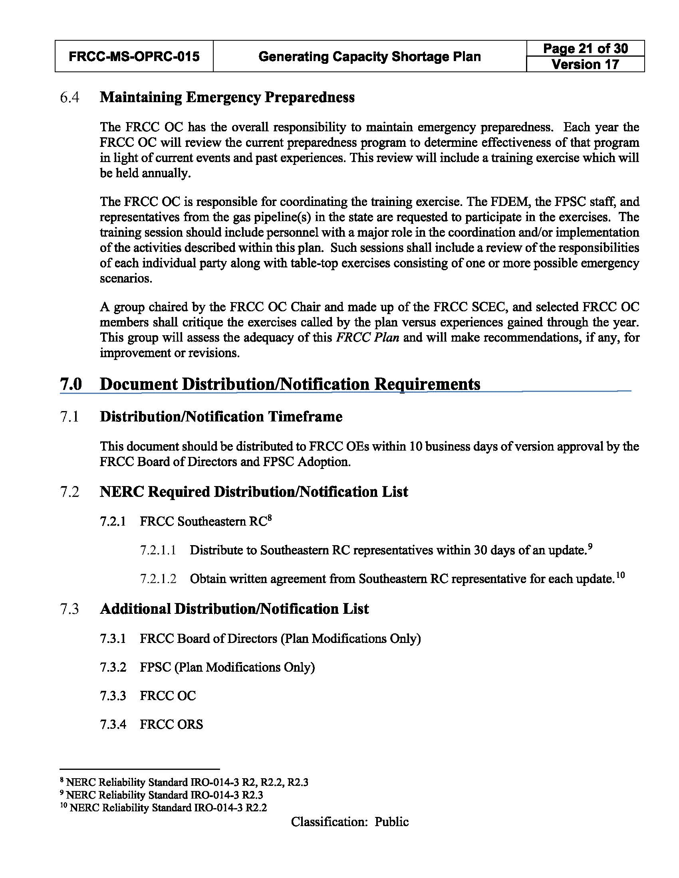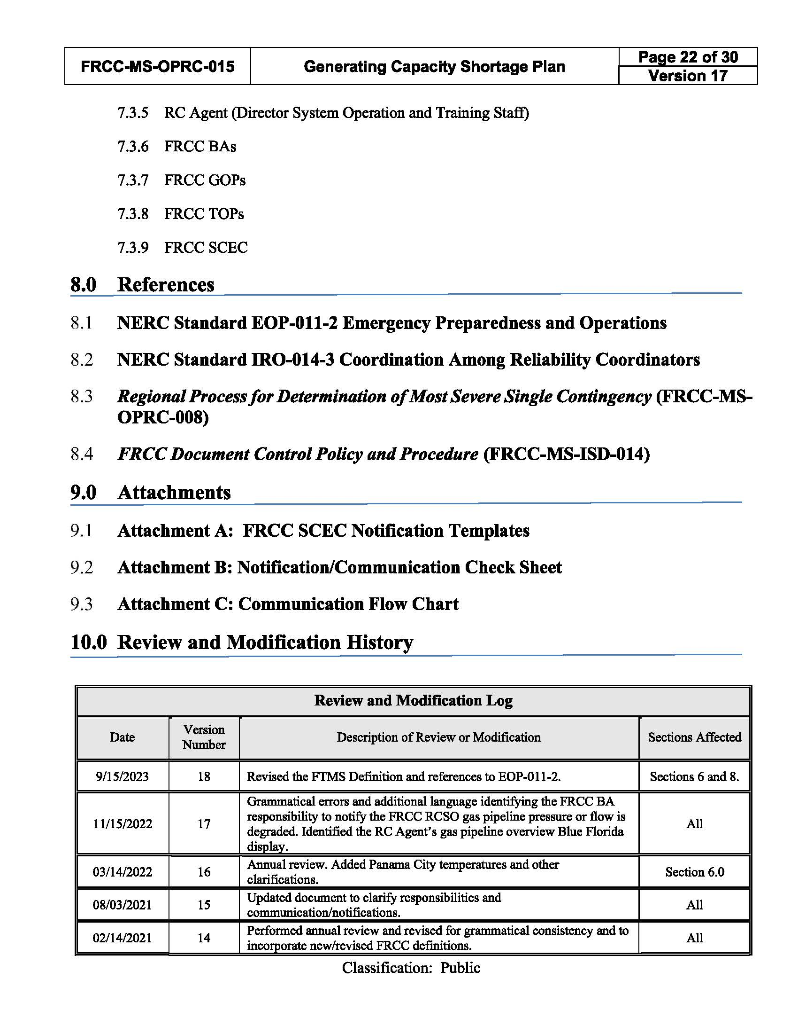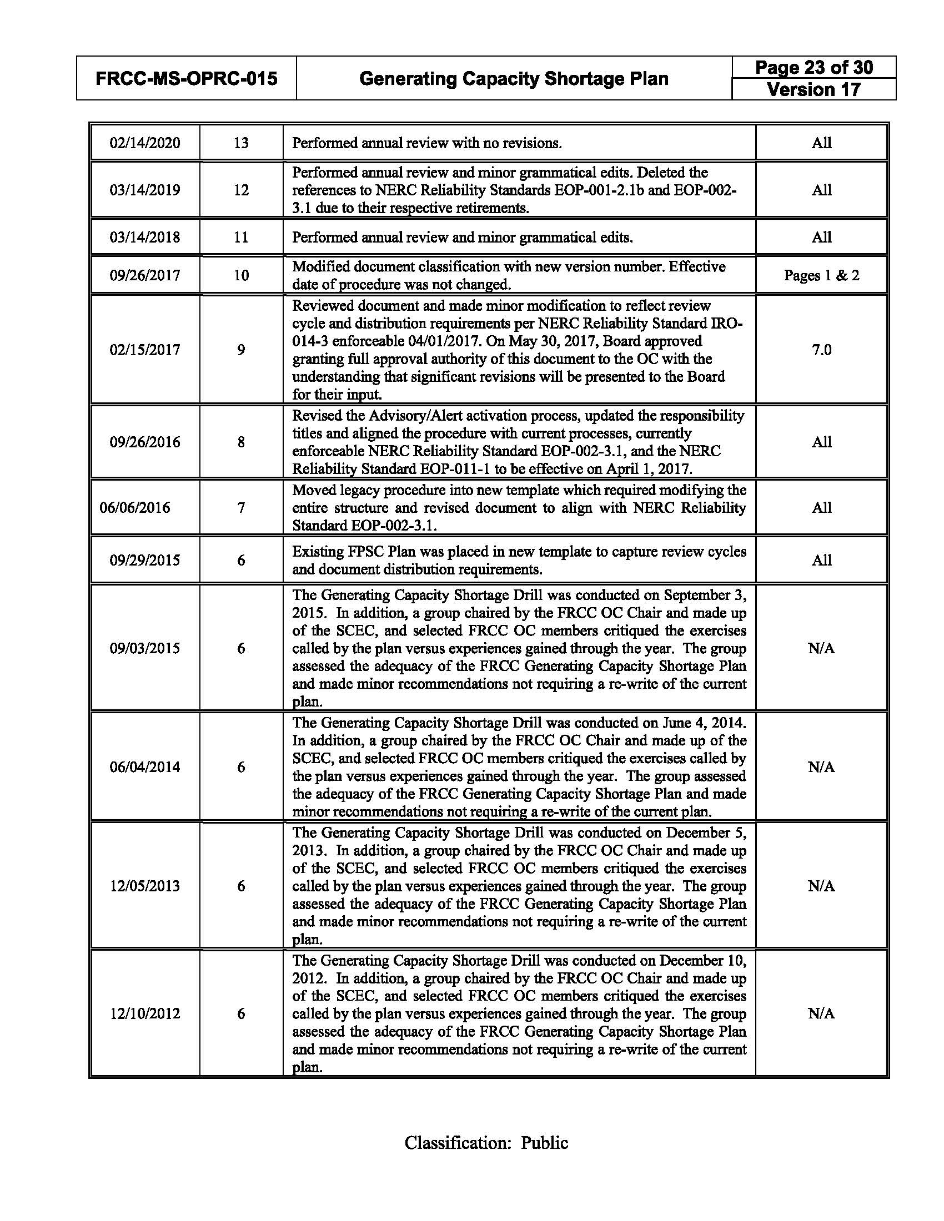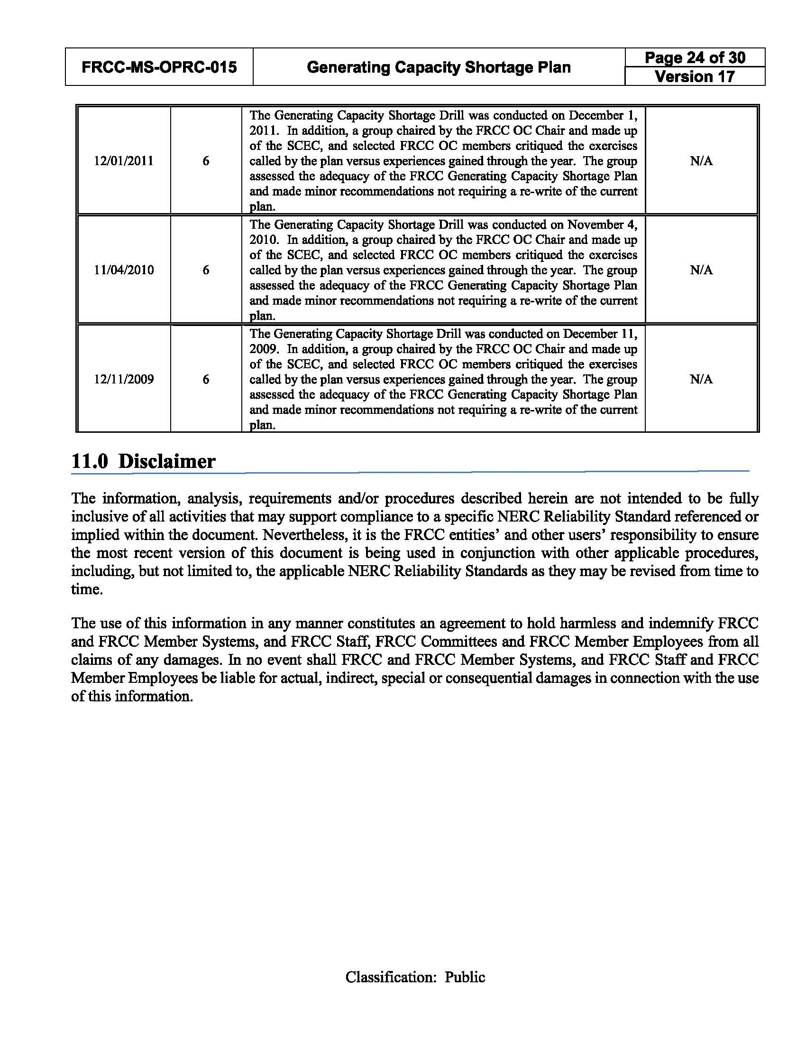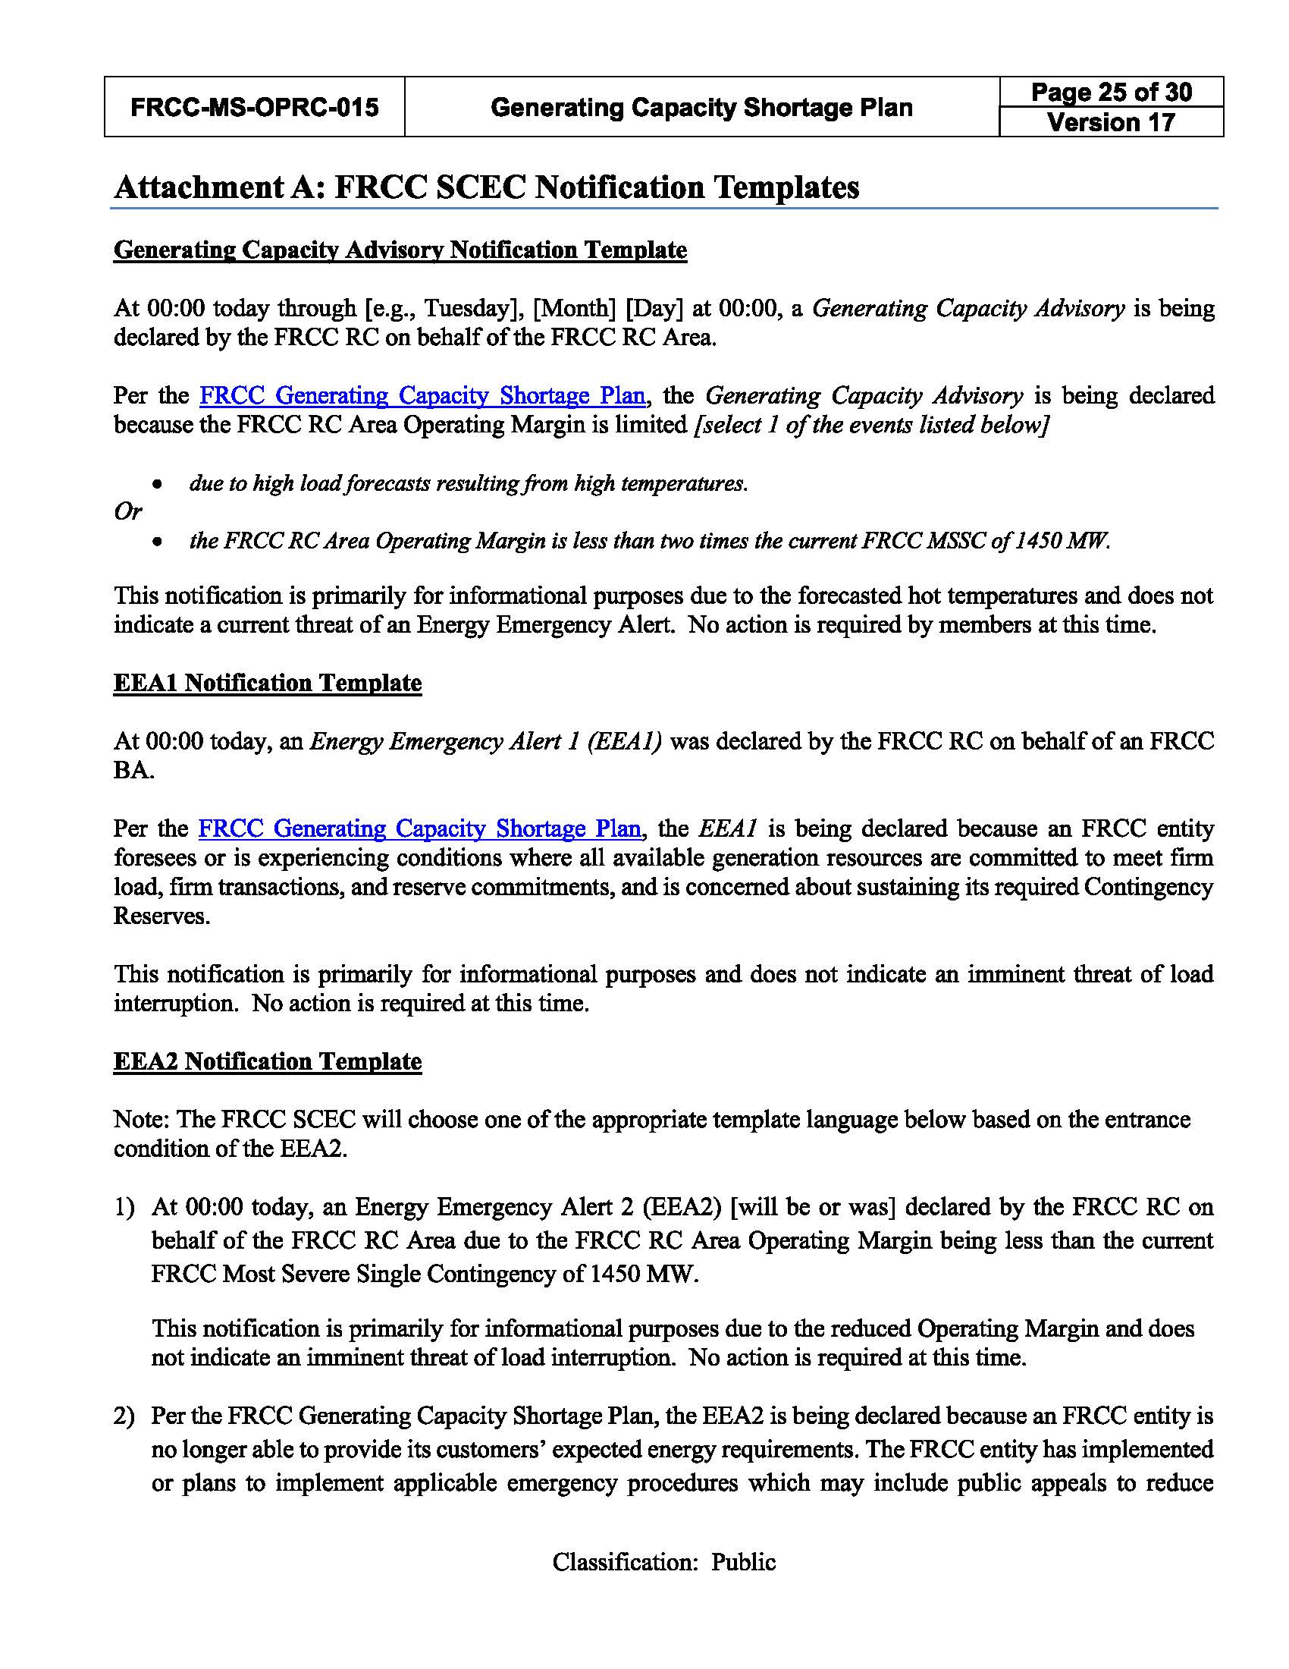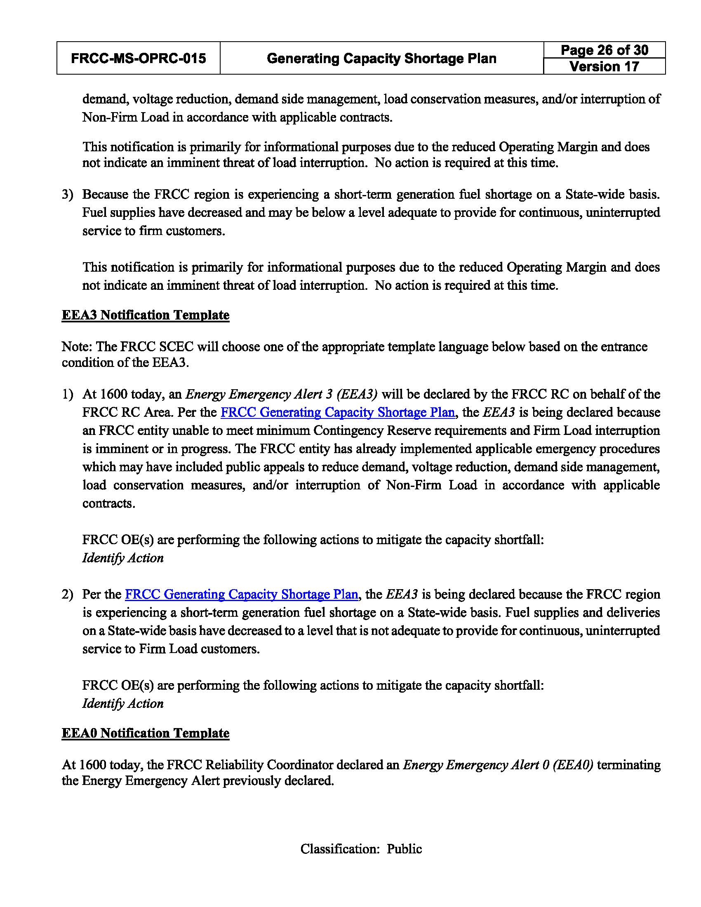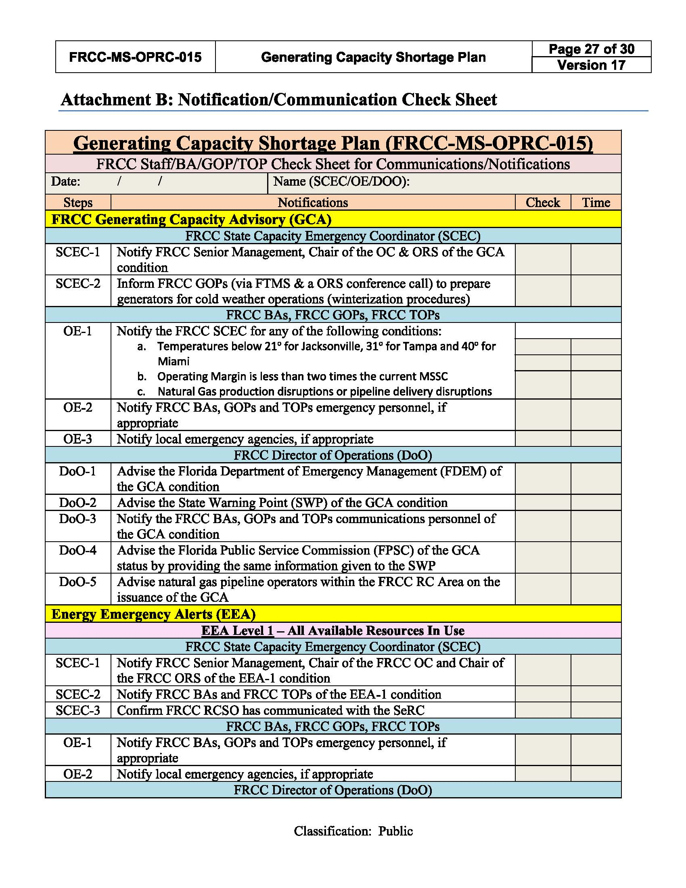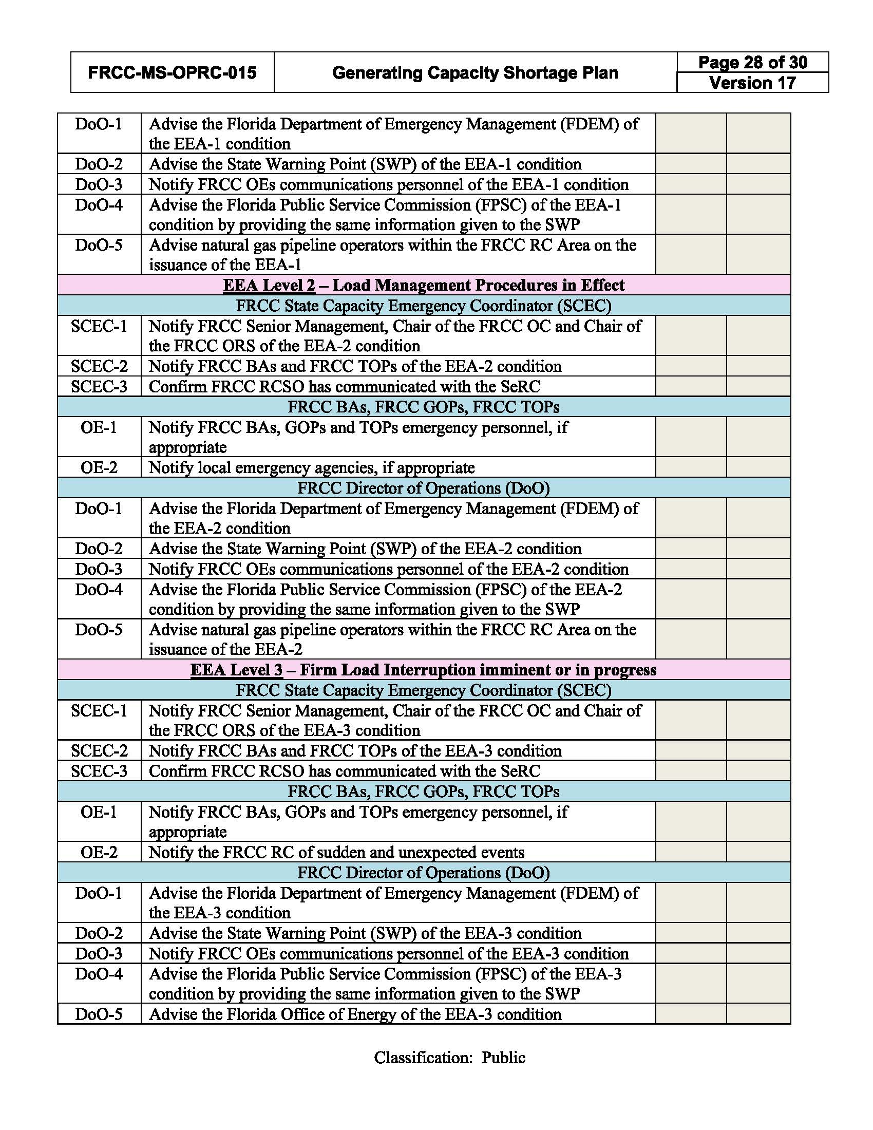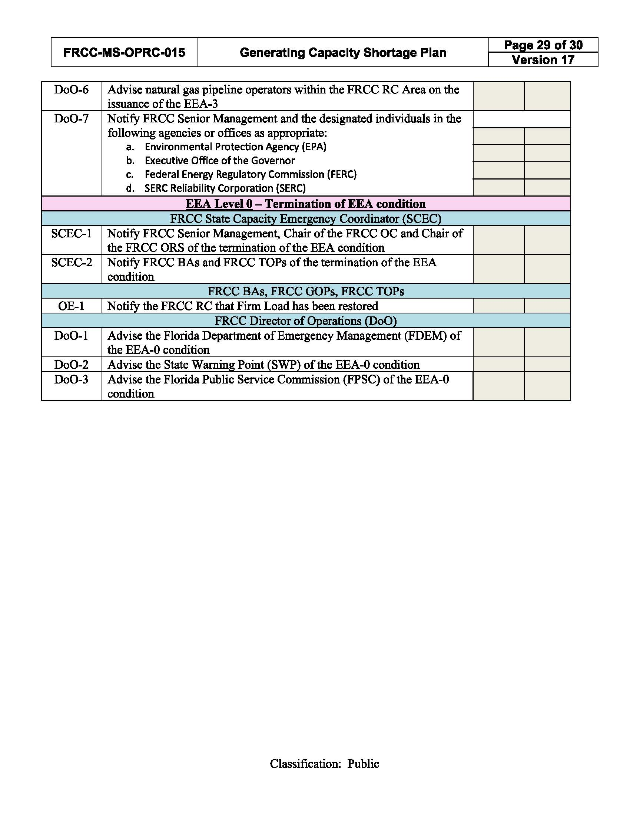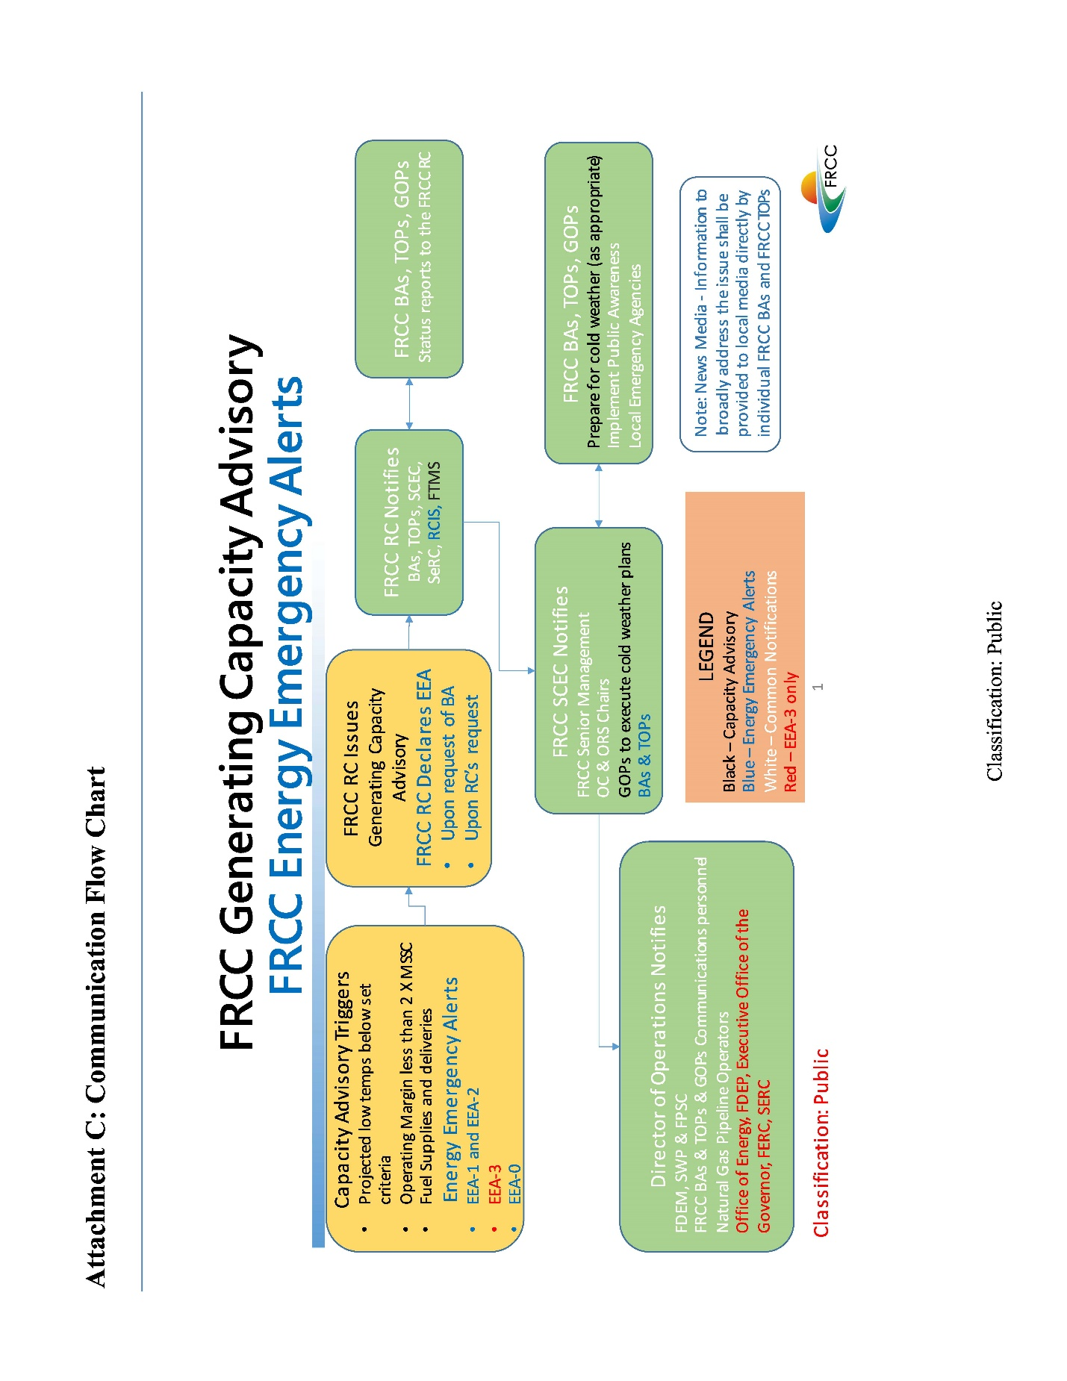

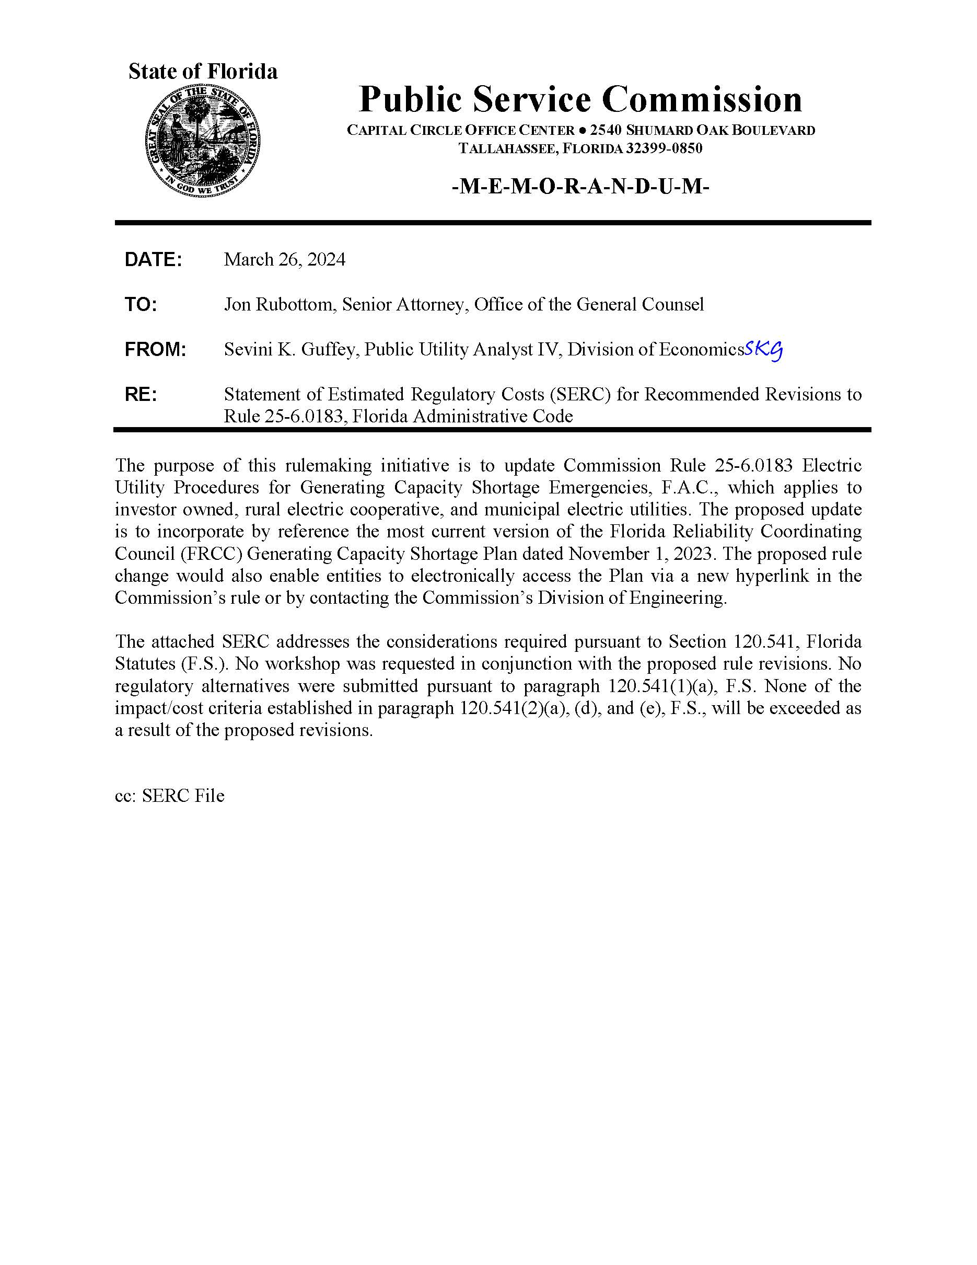

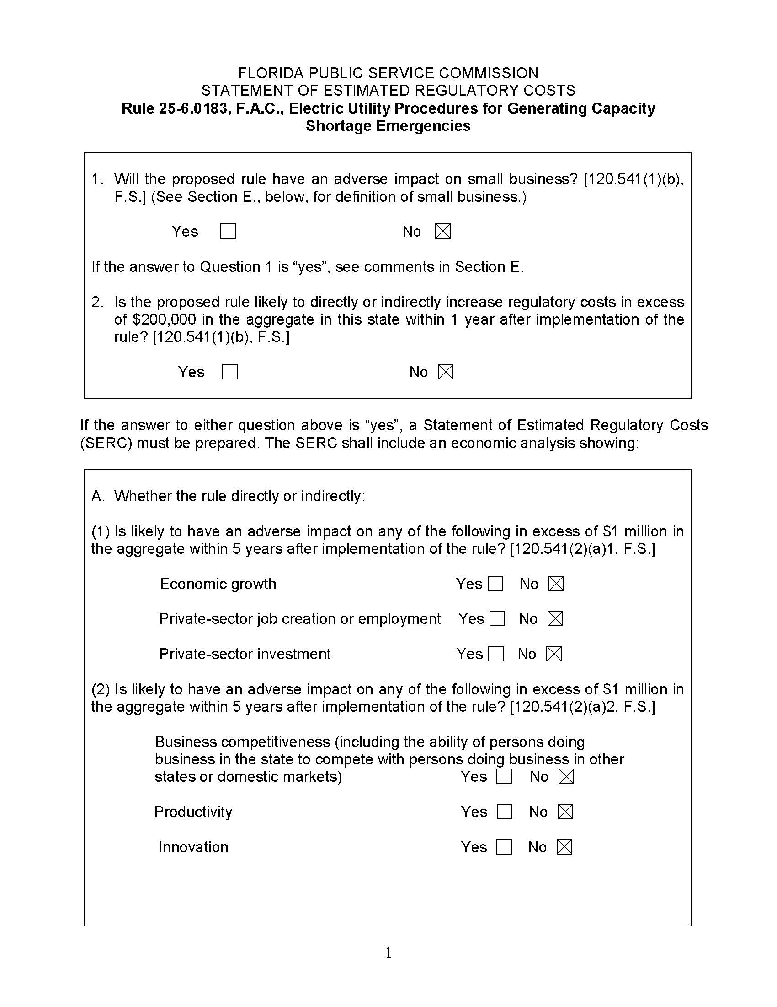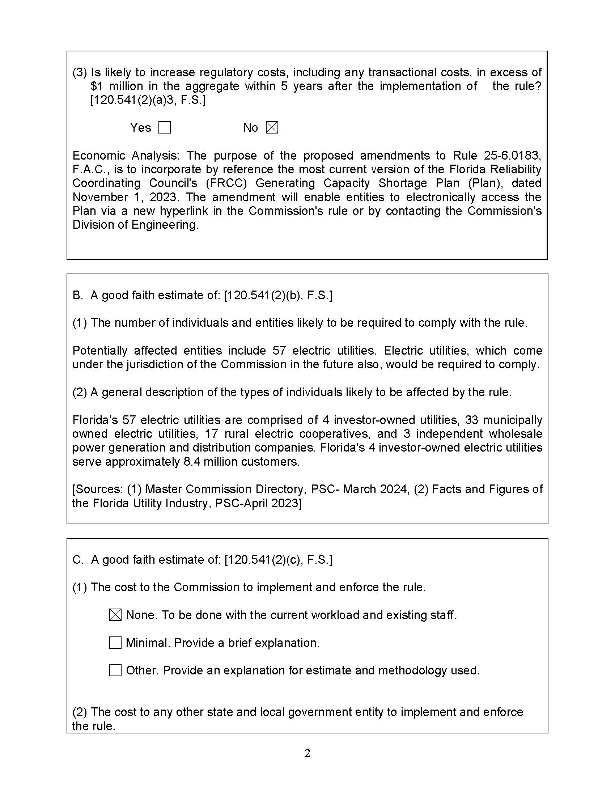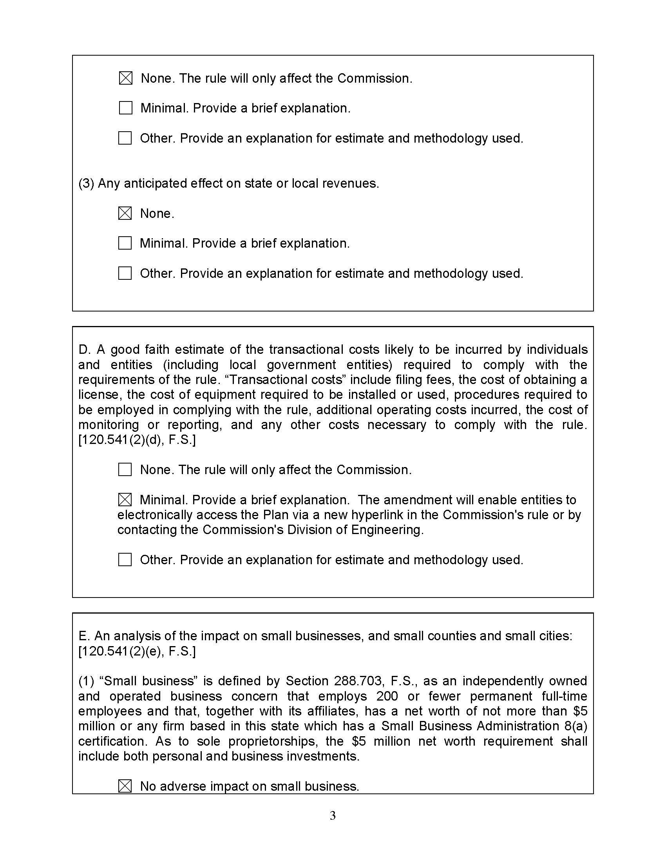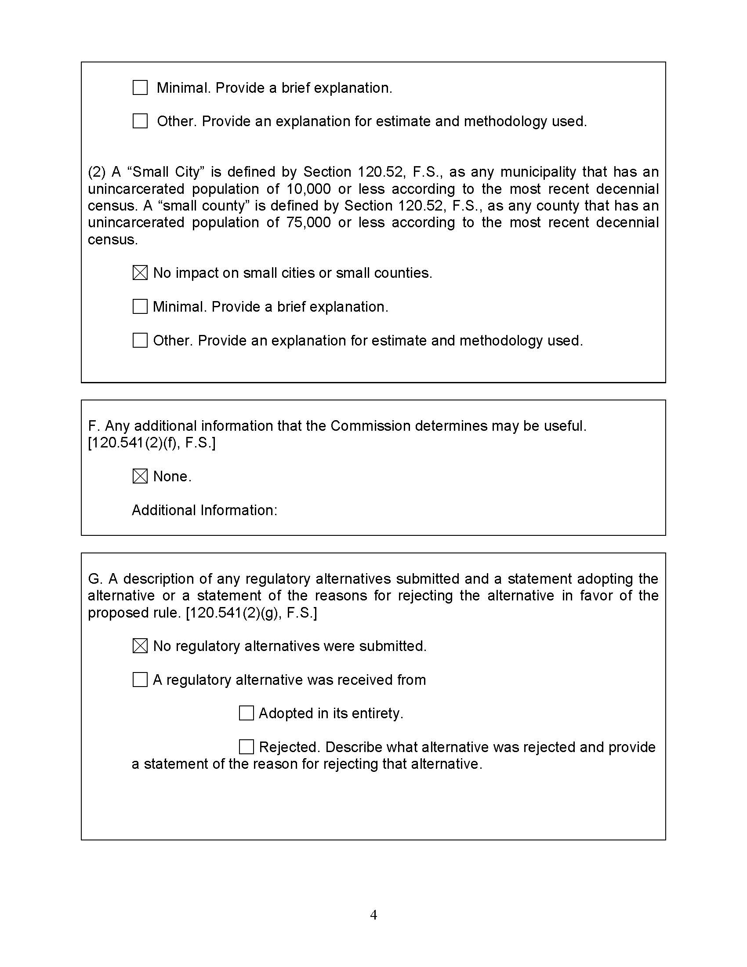

https://www.frcc.com/aboutus/Shared%20Documents/FRCC%20At%20A%20Glance%20.pdf.
Id.
Id.
https://www.frcc.com/SitePages/FRCC-TRANSFERS-REGIONAL-ENTITY-FUNCTIONS-AND-ENTITIES-TO-SERC.aspx.
Section 120.541(1)(b), F.S.
Id.
Section 120.541(2)(a), F.S.
Section 120.541(3), F.S.

